Digital Speech & Debate Best Practices Guide

Authors: Adrienne Brovero, Lincoln Garrett, and Casey Harrigan
May 2020
Contents
Introduction 3
1.0 Speech & Debate Online 4
1.1 Getting Started 4
1.1.1 Online Platforms for Competition 4
1.1.2 Classrooms.cloud 4
1.1.3 Zoom Manually 6
1.1.4 Zoom Functions 8
1.1.5 Suggested Technology 10
1.1.6 Best Practices for Competing 11
1.1.7 Online Coin Flips 13
1.2 Virtual Tournament Administration 14
1.2.1 Slack 15
1.2.2 Adjustments on Tabulation Website 18
1.2.3 Accessibility 18
1.2.4 Security Concerns 19
1.2.5 Pre-Tournament Admin Checklist 20
1.2.6 Scheduling 23
1.2.7 Judging 23
1.2.8 Tasks During Tournaments 24
1.2.9 Award Ceremonies 26
1.2.10 Shipping Trophies 26
1.3 Livestreaming 27
1.3.1 Why Livestream? 27
1.3.2 How is it Organized? 28
1.3.3 Livestreaming to YouTube 29
1.3.4 Livestreaming to Facebook 34
1.3.5 Livestreaming Award Ceremonies 36
2.0 Event Specific Notes 40
2.1 Congress 40
2.1.1 Example Set-Up 40
2.1.2 Overview 40
2.2 Policy/LD/PF 41
2.2.1 Example Set-Up 41
2.2.2 Dealing with Tech Issues 42
2.2.3 Debating with Remote Partner 42
2.3 Extemp 44
2.3.1 Example Set-Up 44
2.3.2 Drawing Questions 44
2.3.4 Prep Rooms 45
2.4 Interp Events 45
2.4.1 Example Set Up 45
2.4.1 Live Performances vs. Pre-Recording 46

Introduction

Due to restrictions related to COVID-19, the University of Kentucky hosted the 48th Tournament of Champions (TOC) in a virtual format. While digital speech and debate is not new, this was the largest online tournament to date. Switching to an online format required reengineering the entire tournament from the ground up, identifying technological and practical solutions for an evolving platform and designing norms and standards of best practice to produce a high-quality and smoothly-functioning experience for the over 1,100 participants and countless coaches, administrators, and friends and family watching from home.

We share the speech and debate community’s strong conviction in the value of in-person competitions and view them as absolutely indispensable when feasible. Yet, it seems likely that the 2020-2021 speech and debate tournament calendar will be impacted to some degree by ongoing public health issues. Many tournament hosts may face the choice between hosting online or cancelling their tournaments entirely.

Rather than acting as a burden, we hope that the temporary transition to digital venues can be a moment of adaptation and growth for speech and debate, allowing the virtual format to reduce barriers to access and encourage greater participation than ever before. The challenge is tremendous and will require the collective work of all members of our larger community: students, coaches, tournament directors, major organizations, administrations, and supporters. But we believe it can be done and the success of the 2020 TOC is one small, but real, data point supporting optimism in this regard.

This manual is an attempt to organize everything we learned during the five weeks between announcing the move online and hosting the Tournament of Champions. Our hope is that it can provide a useful guide to streamline other tournaments’ transition to an online environment, while also productively adding to the conversation concerning best practices relating to speech and debate online.

1.0 Speech & Debate Online

1.1 Getting Started

1.1.1 Online Platforms for Competition

Speech and debate competition online requires the use of technological platforms to connect the competitors and judges. There are currently two main options for tournament hosts when choosing an online platform, but the space is rapidly evolving and new options could emerge in the future.

At the time of this writing, the two most viable options are Classrooms.cloud and manually using Zoom rooms. For the purpose of this manual, we will refer to this second option as the ZRM method, which stands for “Zoom Room Managers”.

We will describe both options, including their strengths and weaknesses.

1.1.2 Classrooms.cloud

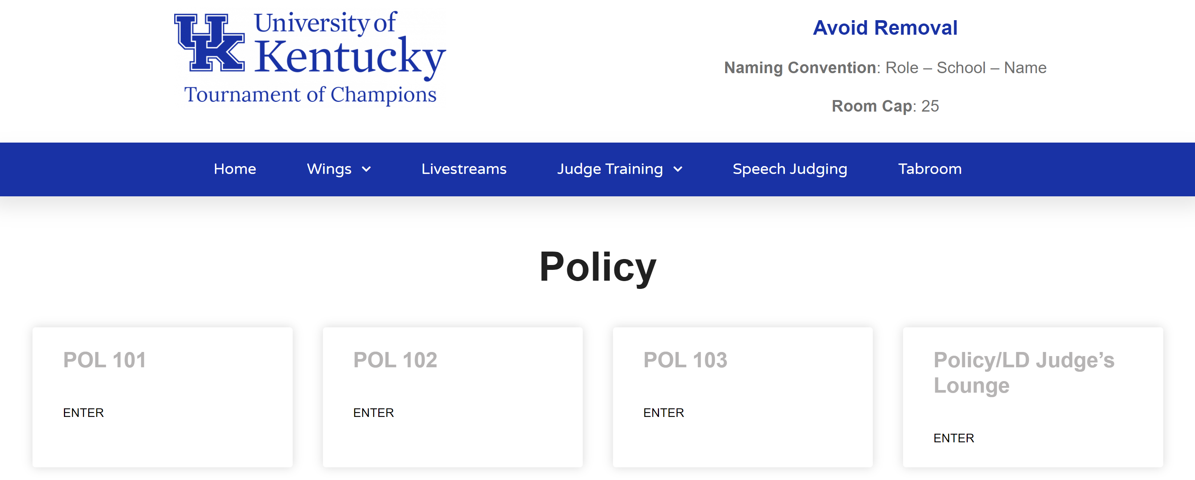

Classrooms.cloud is the platform used to host the TOC. It was created and administered by PHS Capital and uses Zoom to host video meetings. This option involves having a dedicated web page that hosts all the meeting rooms necessary for a tournament. The idea is for it to be analogous to a brick and mortar classroom building.

There are many strengths to this platform. It is very stable and streamlined to use, and it does not take many clicks for a user to access the Zoom meeting they need. Rooms can be numbered or named by the host and can easily show up on a Tabroom pairing. Furthermore, rooms can be organized by event (for example: 100-level rooms for Policy, 200-level rooms for LD, etc.). The rooms are in the same stable location for the duration of the tournament. Classrooms.cloud involves little set-up time and effort on the part of tournament administrators. It attempts to mirror what participants are familiar with in face-to-face settings, is easy to learn, and does not require a new set of makeshift protocols from tournament to tournament.

Use of this platform comes with many other built-in features, and the list continues to grow. There are five particularly useful features to highlight. First, the platform allows for heightened security. At the TOC each school had a unique username and password. This avoided providing any passwords publicly and allowed tracking of what usernames were being used to login. This significantly reduced the risk of anonymous trolls disrupting the tournament. Classrooms.cloud also has the ability to track IP addresses and block problematic users from accessing a tournament. Security features are standardized, meaning that with one click all rooms can disable virtual backgrounds, screen-sharing, file-sharing, or recording. Other methods require doing this manually for each room generated and used by a tournament.

Second, Classrooms.cloud comes with a Help Ticket system. This allows users to communicate with tab staff in a quick, uniform way. Troubleshooting occurs much faster because all the key information for tab staff has to be entered before a user can submit a ticket. For example, instead of receiving an email or text that vaguely says, “Judge missing”, the ticket system requires the user to provide context details: who is reporting the issue, what event and room, and who specifically is missing. At the TOC, this meant that we were able to plug the Help Ticket system directly into the platform that tab staff were using to communicate with one another. The detailed tickets and direct routing to specific tab rooms made the information more actionable and easier to resolve than even in the traditional brick and mortar venue. It is difficult to see how the TOC could have ran as smoothly without this capability.

Third, Classrooms.cloud allows for livestreaming and recording of the competition spaces, which created the most viewable and accessible TOC in our history. Participants reported that this level of access greatly benefits the perception of school officials and parents in understanding what makes speech and debate so special.

Centralized capability does not exist currently in Zoom breakout rooms. Breakout rooms can be recorded locally and then shared with tournament officials. Classrooms.cloud, however, allows for centralized recording and storing of videos. This capability meant that we captured every elimination round that happened at the 2020 TOC, the most video from a single tournament in history.

Fourth, Classrooms.cloud allows for centralized oversight that remains highly private, a capability that only exists because it is a unified platform. It comes with a dashboard of all the rooms and how many people are in each room. By clicking a room in this dashboard, users can see all the participants and how they are named, which is crucial to help monitor rooms for security concerns. This type of monitoring does not exist in systems where several decentralized Zoom accounts are being coordinated.

Finally, in a new feature that was not yet available for the 2020 e-TOC, Classrooms.cloud is now integrated with Tabroom.com. This will allow staff and participants to use Tabroom emails and passwords to gain access to the appropriate tournaments and eliminates several cumbersome processes that were necessary at this year’s TOC. With this new integration, a school doesn’t need a unique login and password. The same is true for judges accessing a judge lounge. Second, tournaments will not need to register observers. If a person is tied to a school’s Tabroom account and they sign up for a tournament that is run on Tabroom and Classrooms.cloud, those observers will be able to use their login information to access the tournament.

Other useful features already exist, like timers built into the meeting room page and more will soon be available. Future developments that will further facilitate tournament administration are on-page file-sharing so email chains are not necessary, a system to manage Extemp draw, and an admin dashboard to help tournament staff monitor how many people are in rooms and if they are following naming conventions.

The main drawback to some will be the costs associated with Classrooms.cloud. There are options that exist at virtually no cost (to those with institutional access to Zoom), but those options typically require more labor, people, and coordination. We will discuss those options in the next section.

The costs for Classrooms.cloud can be justified on four main grounds. First, the costs are substantially less than face-to- face tournaments. Second, it greatly lowers the staffing requirements necessary to run a tournament. Third, it comes with many value-added features. Finally, it reduces the overall complexity of the tournament by mirroring face-to-face settings to an online platform. One key benefit of this approach is that it minimizes points of failure due to technology.

1.1.3 Zoom Manually

The other most tested and viable option for running tournaments is using “Pro” Zoom accounts and their breakout room feature to create enough rooms to host a tournament. This approach was spearheaded and refined by Matt Liu and the University of Wyoming debate team.

This approach is based around the concept of Zoom Room Manager (ZRM), a person who helps run the tournament by having access to a Zoom account that can create breakout rooms. A ZRM is generally responsible for creating and managing 3 to 5 competition rooms. Take the estimated room total necessary for the competition as a whole, divide it by 3, 4, or 5, depending on how many rooms each ZRM will be expected to manage at that competition, and that gives an idea of how many ZRM’s are needed.

Each ZRM can produce a link to a meeting room using Zoom, which is what would be put on a pairing instead of a room number. It may require a URL shortener to make it fit on a website like Tabroom or Joy of Tournaments. The same link would be assigned to multiple “rooms” worth of competitions in a given round (because a ZRM is responsible for 3 to 5 of them).

Participants click the link and join the Zoom meeting. Then, the ZRM assigns the appropriate competitors and judges to a breakout room. This process allows the ZRM to assure everyone shows up, their tech works, and is available to help troubleshoot as necessary.

One strength of this approach is cost-related. Many people have free Zoom accounts via their institutional affiliations. As of this writing, a pro Zoom account costs $15 per month for one person. Depending on the size of the tournament and the number of people staffing it with pre-existing accounts with Zoom, the tech costs could be $0.
This approach also has some significant weaknesses. First, there is a question of scale. The more rooms that are needed, the more labor intensive and complex the ZRM method becomes. Some tournaments need 300 rooms, which would necessitate 60 to 100 ZRM’s. That is likely not feasible or nullifies the ability to cost save. Second, many important features are unavailable. Breakout rooms cannot be livestreamed or recorded. Access to the Zoom links may be harder to control due to the amount of public sharing necessary to facilitate adequate coordination among participants and ZRM’s. Third is the problem of points of failure. One malfunction with a ZRM and 3 to 5 rooms are compromised. Technology failure is a somewhat inherent risk in any online tournament endeavor, but the chokepoint being a given individual and their computer heightens the risk compared to web-based platforms.

1.1.4 Zoom Functions
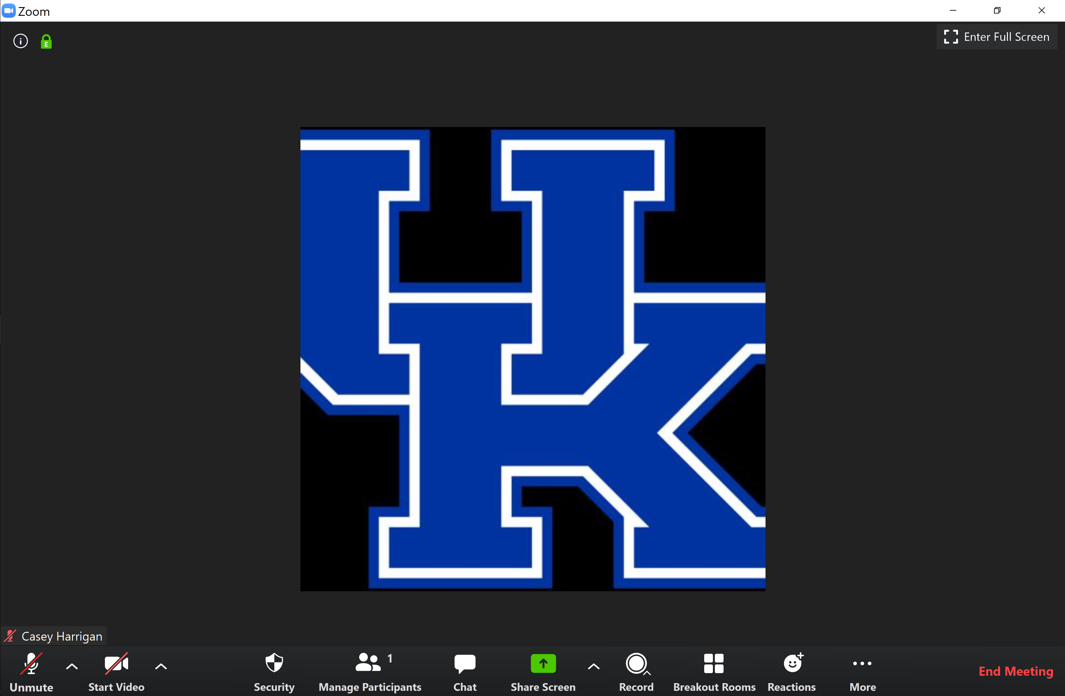

Muting/Unmuting Mic: Alt + A is the keyboard shortcut. If a user is muted and wants to unmute temporarily, hold the Space Bar.

Turning On/Off Camera: Alt + V is the keyboard shortcut.

Manage Participants: Clicking the “participants” icon lets users see who else is in the room, what they are named and who is the designated Host of a room. A Host has special functions in this screen. Right-clicking a participant’s name allows the Host to rename them, mute them or remove them from a room.

Chat: This screen allows users to send text messages to the other participants in the room. The messages can be to everyone or to specific participants. Sending links in the chat is a common use. Participants cannot access chat messages shared after the meeting concludes.

Share Screen: This allows the Host to share their computer screen so all other participants can see it. This feature, as of now, has little impact on speech and debate tournaments.

Record: This button is only available to the Host. It allows users to record what is happening in the room.

Breakout Rooms: Clicking this button produces the following:
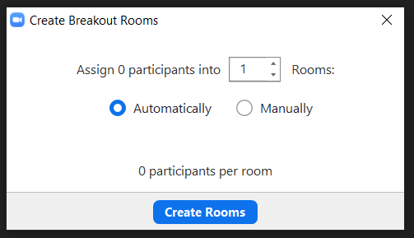

In the case of ZRM, specific participants are assigned manually to a given room. The other use we found for breakout rooms was moving Flight A competition into a breakout room so Flight B could start a round.

More: Clicking the “More” button when a user is the host gives them options to livestream the room to Facebook, YouTube or Workplace by Facebook.

Waiting Rooms: This setting has to be enabled in a user’s Zoom account. It allows the host to individually permit participants into a Zoom room. If the setting is enabled this what the Manage Participants screen looks like when someone joins a meeting:

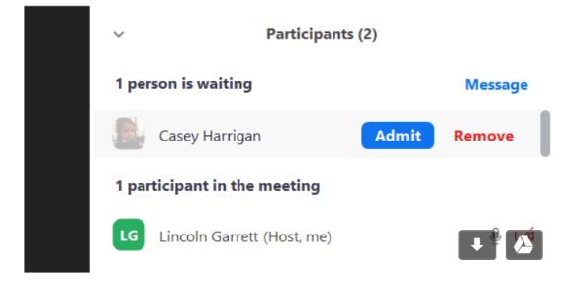

This is what Waiting Rooms look like for a participant:

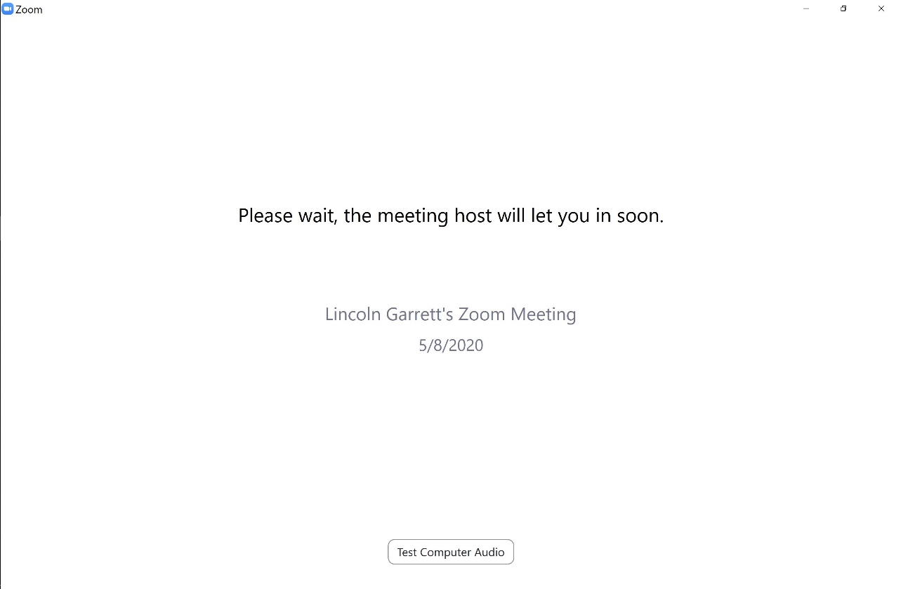

1.1.5 Suggested Technology

Important Note
First, practice with an existing laptop to establish a baseline. In early testing, what comes built into most laptops (webcam, audio and microphone) is often sufficient for speech and debates.

The issue that impacts video and audio is most often the internet connection, not hardware.

There are some genres of technology that will noticeably improve performance. However, such add-ons tend to be discretionary (they improve performance), not strictly required for participation.

Ethernet and Adapters
This is our most recommended piece of technology. Debate teams should be ready to debate from their home and, in that case, plan to plug into their router with an Ethernet cable. Doing so can dramatically improve internet speeds and prevent disconnection or lag. Some laptops do not have Ethernet plugs, so it may be necessary to purchase a USB-to-Ethernet adapter. These are typically $15-$25, depending on length.

Webcams
Practicing joining a Zoom meeting will reveal many existing issues with webcams. Most webcams are, for the purposes of speech and debate, interchangeable, so we recommend defaulting to what is most in-line with budget and availability.

Headphones and Microphone vs Headset
At the TOC, competitors used a wide array of configurations. Many products performed acceptably well. The most important thing about competing with a microphone is practicing and internalizing a way of speaking that maintains a consistent connection with the microphone. Clear volume requires speaking directly into a mic. Solutions found included headsets and clip-on microphones. Headphones and a USB microphone could also work if a student practiced a comfortable speaking configuration.

Additional Monitors
Additional screens are not necessary if participants manage space well on their existing computers—competitors can definitely succeed with one screen. However, an extra monitor may be a nice solution, particularly for those participants who have trouble having many programs and tabs open in the first place. An extra monitor can help have the video conferencing open, speech documents, files, chat applications, etc.

1.1.6 Best Practices for Competing

Practice Makes Perfect
One of the best ways to improve an online tournament is encourage the participants to practice giving speeches virtually. Students should not be joining a Zoom for the first time during Round 1. Practices reveal large technology issues and begin creating a reservoir of troubleshooting knowledge.

Digital Bus
The person in charge of a school’s entry should set a designated time prior to the first pairings release of day so they can confirm that all judges and participants are at their computer and ready to participate in each given round—analogous to “meeting on the bus” prior to departure for a physical tournament.

Tech Time
When adapting schedules to an online environment, factor in technological lag or failures. At the TOC, each team was given 15 minutes of “Tech Time.” If the debate had to be paused for technology related reasons, one team’s Tech Time would begin to count down. If a team used all their Tech Time before the round ended, they would be required to forfeit.

The TOC, fortunately, did not have many technology-related issues. We are not sure how closely Tech Time was tracked. A lot of judges are used to delays in a round due to student issues (computer crash, bathroom break, slow email, etc.) No debate was decided solely on Tech Time.

Going forward, we recommend that 10 minutes of Tech Time per team, per round be factored into schedules.

Cameras On
It should be required that cameras stay on for all participants and judges. First, this is a necessary safeguard against outside assistance. Second, it is an important accessibility issue. Some participants may have a difficult time understanding audio without a corresponding image. Third, leaving cameras off degrades the social and interactive elements of online debating. These should be preserved as much as possible if face-to-face tournaments are restricted.

Muting Microphones
Those who are not the active speaker should have their microphone muted.

Phone Dial-In as Back-Up
In the event of extreme technology failure, a participant or judge should use their phone to call into the Zoom meeting. The steps are:

1. Call 415-762-9988 or 646-568-7788 and follow the verbal instructions.

2. Enter the meeting ID.

3. Enter your participant ID. If you do not know your participant ID, simply press the # key.

Naming Protocols
When users enter a Zoom room, their name appears on that room’s Participant List. It is best practice to have people include identifying information in their names. There were four name types used the TOC: “Judge”, “Participant”, “Observer”, and “Tab”. For example, “Tab—Lincoln Garrett”. This helps tournament staff identify who is in a room.

Check-in Time
When a pairing for a round is released, within the first ten minutes, all competitors and judges should enter the assigned room. The purpose of an early check-in is to:

1. Verify participants are online
2. Ensure video and audio works for everyone.
3. Set up any email chains.
4. Engage in argument disclosure in a timely fashion.

Participants should then mute their microphones and turn off video but stay connected in the room. They can then prepare as normal.

1.1.7 Online Coin Flips

Tabroom now has an online coin flip management system that avoids the need to do a physical flip in a virtual competition. Coin flip execution can be time-consuming in person. The intent of this feature is to reduce the time and errors involved in real-time coin flips.

Administration Side
1. Select “Settings”, then “Event”, then pick the correct Event on the right side, then choose the “Tabulation” tab. Toggle “Use Online Coinflips” to “Yes”.

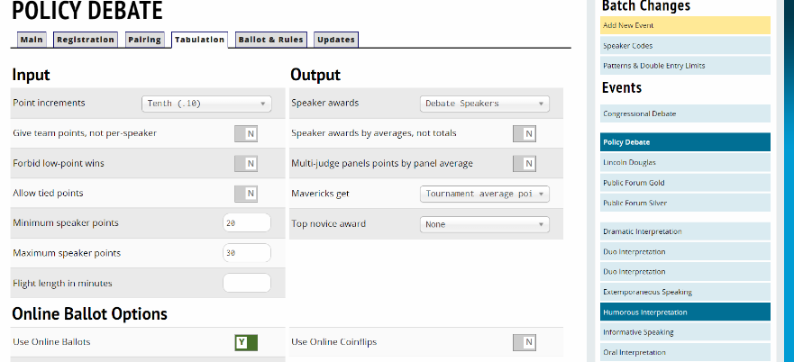

2. Choose “Schematics”, then pick the “Event”, than click the designated round. Then, click “Actions”.

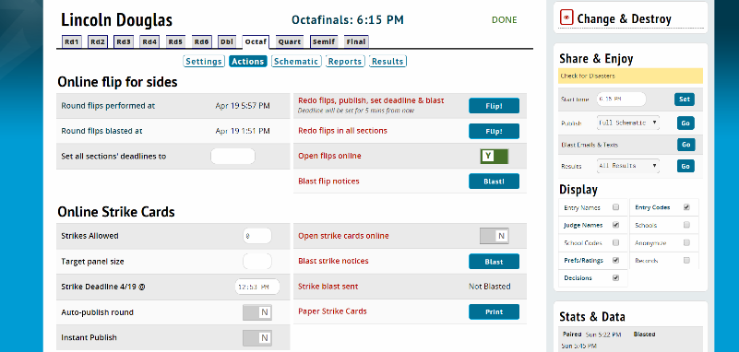

This is the screen where Tab performs the flip, sets the deadline for teams to respond, and blasts that information to participants and coaches.

3. To monitor progress after blasting the information out, click on a room on the schematic for a given round:

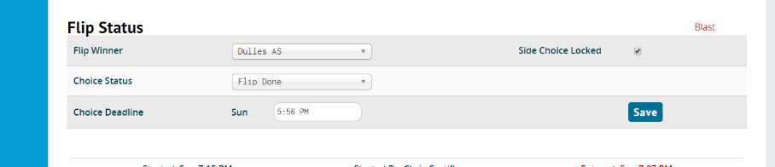

Participant Side
Participants get an email blast with a link that takes them this screen:

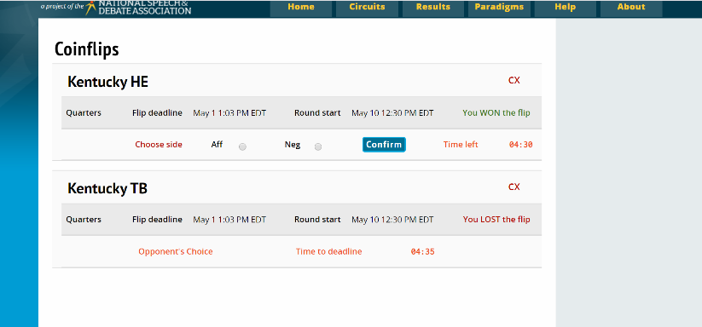

Teams that win automated coin flips are given the option to choose their side within a specified timeframe. After side selection, an email blast alerts everyone to the assigned side.

In Public Forum, this process has an additional step based on the second choice involved in determining sides and speaking positions. The winner of the automated flip will have 5 minutes to select whether they want to be pro/con or 1st/2nd speaker. Once they choose, the other team will be texted and can go to the same screen via the same links to make the other choice. Once that choice is made, both teams will be able to see which side/speaker position they are in on that flip screen, and they will also get a text/email blast. (Additional details here).

1.2 Virtual Tournament Administration

Four “big picture” decisions need to be made before administering an online tournament:

- Where will the event take place? (Choose the online platform; see options above)

- Where will tabulation take place and pairings be released? (Tabroom, Joy of Tournaments, Speechwire, etc.)

- How will participants communicate with tab staff?

- How will tab staff communicate with one another?

1.2.1 Slack

We recommend Slack as the best tool currently available for tab organization. It does have a learning curve, but once people become familiar, it has many useful functionalities. Once set up, staff should be encouraged to customize (e.g. notifications, Do Not Disturb times, profile pics) their account, install it on their devices, and practice using it prior to the tournament so everyone is up to speed when the tournament starts.

Set Up
This is what a Slack page looks like:

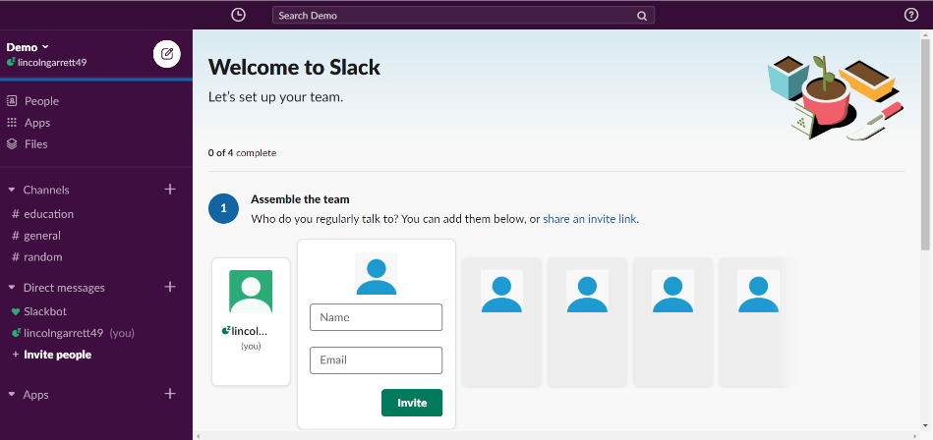

Start by adding members (the Tab and/or event staff). Conversations can be organized via Channels, so Channels should be set up based on groupings of staff (e.g. a channel for each event’s tab room, a channel for all tabs). This is way to keep topics compartmentalized, while still having the ability to converse across events. Channels can also be locked, so that only certain participants have access to them. For example, if students help staff the tournament, tournaments may want to have locked channels for tab rooms so that students do not have access to sensitive tab discussions.

Here is the Channel list used for the TOC:
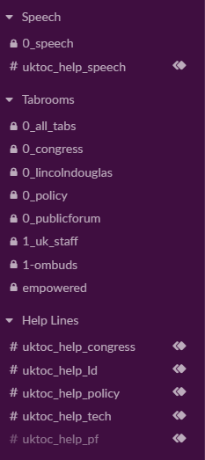

Users can create Sections, which allows them to group the Channels. In this example, Speech is set at the top as a Primary Focus. It can be changed throughout the tournament as needed.

Help Tickets
For the TOC, the Help Channels were linked to the Help Ticket System on Classrooms.cloud. When someone submitted a ticket, it would appear in a Gmail account that would be forwarded to that event’s Help Channel on Slack. For instance:

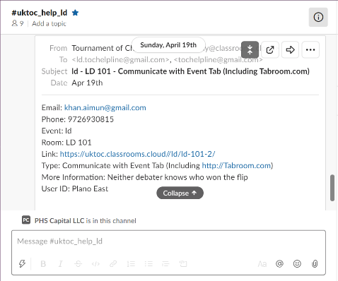

The tickets provide contact information of the person asking for help, the room they are in, the link to that room and a description of the issue. It is a good idea to have a particular person responsible for delegating help tickets for resolution to make sure none fall through the cracks. It is also a good idea to use the “heavy check mark” Slack emoticon to mark when a help ticket has been handled, so there are not redundant efforts to resolve the same problem. This system was a key factor smoothing operations at the TOC.

Threads
Another key Slack feature is Threading:
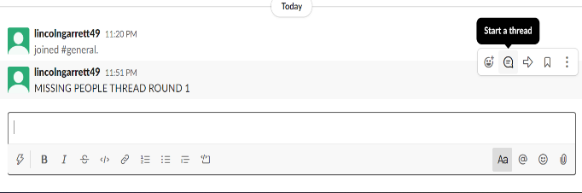

When a thread is made, it looks like this:
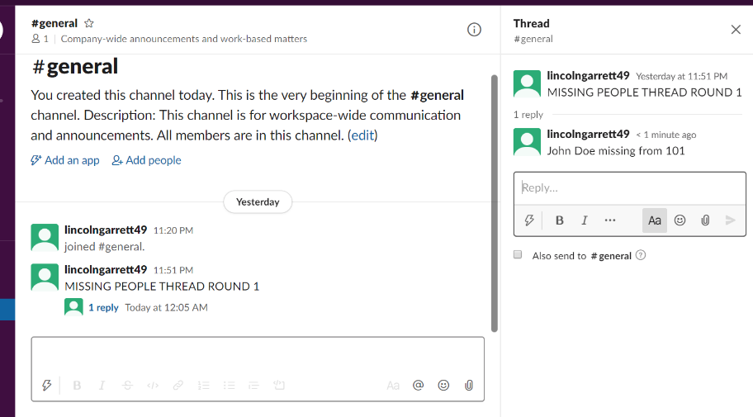

Threads allow users to respond to specific messages and include a smaller subset of members on a given channel in a conversation. The notifications for threads occur at the top left of the Slack page and users can see all the unread thread messages they have. Without threads, information can get lost by needing to scroll through many unrelated messages. When monitoring the Slack using a phone, verify that notification settings are set to “Notify me about replies to threads”.

An additional Slack feature allows lengthier paragraph-style responses as opposed to the single-line default. Normally, when users hit Enter, it automatically sends the message to the Slack. Sometimes users might want to have a longer message broken up into paragraphs or lists. To allow this, click on the user Name at the top left of the Slack workgroup, then “Preferences”, then “Advanced”. Click “Show send button” – this will allow users to use the “Enter” button to add new lines to their messages and to click “Send” to actually send messages. This also reduces the number of individual messages that need to be sent, because they can be combined, which helps reduce excess notifications and traffic on the Slack.

Highlighting Important Information

A couple of basic features help users draw attention to important information in Slack. “Pinning” posts allows users to pin information to the top of a Slack channel. For example, passwords or other important information staff might need, like protocols for starting rounds. To pin an item, click on the post, and a menu will open up with three dots on the right. Click on those dots and select “Pin to channel” – this will keep messages at the top of the Slack channel so they won’t get lost in the large amount of traffic that occurs with each round.

Bolding is another useful feature. For example, at the start of each round, start a Missing Persons thread (as in the last graphic above), and label it for the round. It can be bolded to make it stand out more amid the other traffic on the thread, which will make it easier to find. The thread can report in a central location all the people that staff are trying to locate for that round (e.g. Missing Judge Smith, room 103), and make sure to check them off as they are resolved.

1.2.2 Adjustments on Tabulation Website

The main adjustment to be aware of is the room list and the schedule. Tab will need the room list to match the platform and naming conventions they adopt (whether the rooms have names or if they are Zoom links that need people to click). The other main adjustment is updating the schedule. Tournament schedules needs to account for participants competing in different time zones and being lengthened to include “Check-in Time” and “Tech Time.” Tournaments may also wish to use the coin flip management system described previously in “Online Coin Flips”, which requires set-up.

1.2.3 Accessibility

Accessibility impacts speech and debate along multiple axis. Online competition creates new issues, potentially exacerbates existing ones and possibly makes improvements to others. These issues need to be identified and discussed in a collaborative way to arrive at optimal solutions.

This section is not designed to be comprehensive or the last word on any of these issues. It is a starting set of issues that were brought up and worked through during the planning and execution of the 2020 Tournament of Champions. We look to engage the community further and provide updated awareness and solutions for tournament administrators and, in turn, to benefit from the experience and suggestions of others in the speech and debate community.

Cost and Technology Disparities
This is not a new issue for speech and debate, but online competition can potentially exacerbate it in unique ways. The ability to buy better equipment should not determine the ability to fairly compete. Things we explored to help mitigate these issues include:

1. Market research on low cost, but effective, equipment. This includes doing beta tests before recommending any equipment.

2. Technology grants through the JW Patterson Foundation. Regular season tournaments typically offer fee waivers for programs in need. The hope is that programs’ budgets remain stable enough to that they can use the savings from reduced in person travel costs to acquire necessary equipment and cover entry fees.

3. Judge instructions. We alerted judges that quality of video and audio equipment should not be a factor in making decisions. Instructions could be improved with broader community engagement on the issue.

Sensory Disparities
The main issue we navigated was how to best duplicate face-to-face interaction for participants and judges who have differing sensory abilities. The main focuses were on variations in hearing and auditory processing, but also included other aspects, such as sensory overload due to screen time.

Reducing microphone latency is one step that can improve the situation for those with variations in hearing or auditory processing. Because the TOC occurred on a compressed timeline and due to COVID-19 related supply chain issues, we wanted to give participants maximum flexibility in acquiring basic equipment. The next step is to work with the community to establish best practices and recommended technology that mitigate audio processing problems.

1.2.4 Security Concerns

Ensuring the security of participants should be one of the most important priorities for tournament administrators. The security issue has several variables. We made reasonable progress on these issues in the lead up to the TOC and are optimistic more can be done.

Zoom Bombing
Zoom Bombing is the shorthand for a outside party disrupting a Zoom meeting. The more public and accessible links to zoom meetings and passwords are, the greater the risk of this occuring. One feature added later in the TOC planning process was the “Waiting Room”, detailed in an earlier section. Waiting rooms are a good feature to use if you are creating Zoom rooms manually and sharing them publicly. The TOC used layers of password protection via Classrooms.cloud, so we avoided this issue.

Online harassment
A related concern is harassment during competition. This is not unique to an online format. Tournaments should have procedures for handling instances of harassment and those should be made transparent in written documentation like invitations. The unique element online competition brings is heightened risk of anonymity. The solution for that utilized by the TOC was two-fold. First, we created unique passwords for every school that could be tracked. Second, we strictly enforced naming conventions so people in Zoom rooms would clearly identify users. Tournament procedures for handling instances of harassment did not change significantly due to the move online. TOC policies are determined by University entities that have expertise and jurisdiction in handling such matters.

Recording and Consent
One issue with online competition is recording without consent. By using Classrooms.cloud, we were able to disable recording in competition rooms. This did not completely eliminate the issue because a participant could still capture their screen using a local program but did minimize the risk.

The next step on this issue is community discussion about what models of consent are optimal, written and verbal, under what conditions can someone record, under what conditions can recordings be posted on the internet, and what, if any, enforcement can maintain these standards.

1.2.5 Pre-Tournament Admin Checklist

There are some unique elements of an online tournament that need to be incorporated into the typical pre-tournament issues like collecting fees, hiring judges, and making sure judging obligations are met.

Video Releases
There is no one-size-fits-all solution in this area. Privacy rules and laws differ by location and institution. Each school may have different requirements. Tournament administrators should consult appropriate officials and experts about how to handle digital tournaments and opportunities for participants to be recorded. These policies should be clearly highlighted in tournament invitations.

Video releases also intersect with norms and best practices related to consent and recording; what is legally enforceable may differ from what the community believes is in the best interest of participants. This is why consulting with appropriate experts is important. This does not mean lack of legally enforceable models of consent leave the community with no means to adopt the most suitable norms related to video recordings. Rather, tournament administrators should avoid creating tournament requirements that are legally tenuous.

Code of Conduct/Honor Codes
Tournament administrators should consider having participants affirmatively agree to a Code of Conduct or Honor Code for the duration of the tournament. The two biggest points of concern prior to the TOC were receiving outside assistance and completing all preliminary rounds. These issues are not unique to online tournaments. We found Honor Codes to be an academically proven means of reducing the propensity of things like cheating. Tournaments should strongly encourage coaches to discuss both the tournament and the school’s honor policies prior to competition. No instances of receiving outside assistance came to light during the 2020 TOC and no participant suddenly disconnected or dropped out of the tournament after they were no longer eligible for elimination rounds.

Contact Information for Designated Adult in Charge
Tournaments should ensure they know who is the person in charge on the given weekend for each school. This may differ from coaches listed on Tabroom. Adults in charge need to be made aware they are responsible for knowing the whereabouts of their participants and judges and be able to quickly establish contact with of them throughout the weekend. Tournament staff should have a contact list ready to contact the designated adult in the event someone from that school is missing at Check-in Time.

Mailing Addresses for Trophies
Tournaments should collect this information through an intake option like Google Forms.

Distributing Passwords
It may be necessary to share platform log-in credentials. In the case of ZRM, the most common way this is done is a shared Google Sheet. For example:

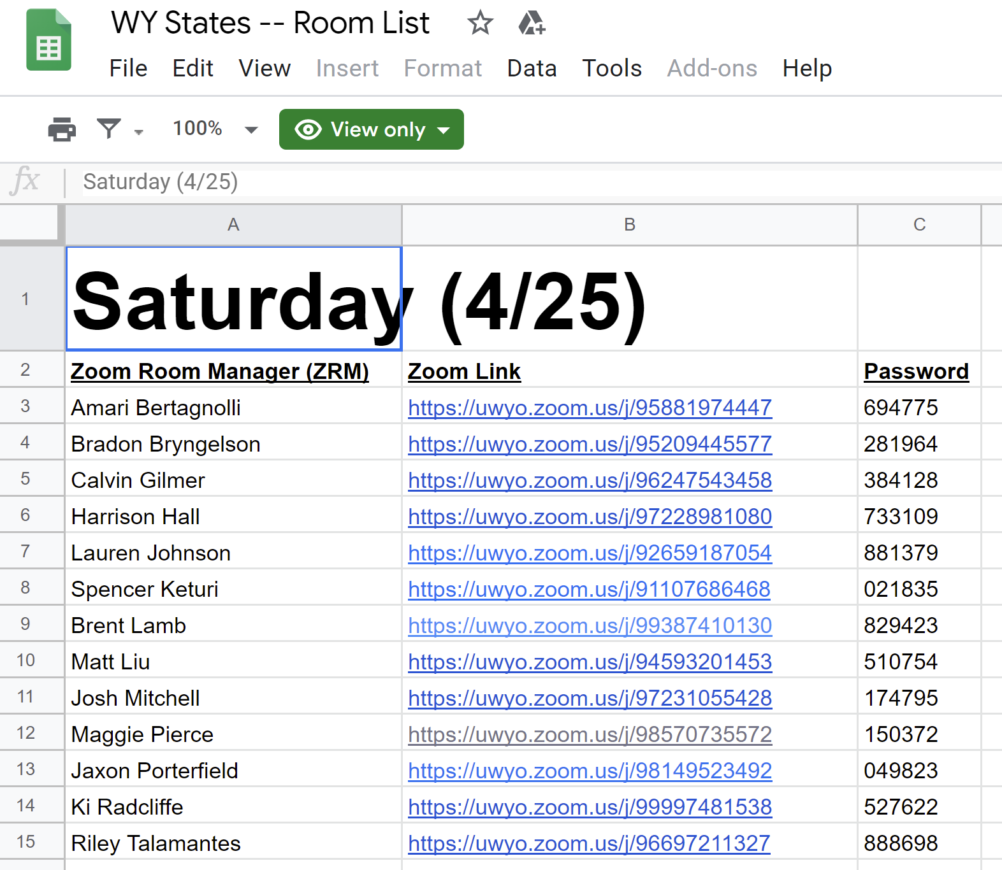

For Classrooms.cloud, all that is required is the list of emails and what schools they correspond with to send passwords to. This list is easily generated on Tabroom: choose “Entries”, then “Reports”, then “School List”, then click the “Full Info” button in middle of screen. Similarly, if using a Google Form, like the TOC Contact Form which asked for an email for the person in charge, a similar spreadsheet list could be created.

Staffing
The ZRM method requires one person for every three-to-five rooms at the tournament. For the TOC, we had one person for roughly every six rooms using Classrooms.cloud. With proper introduction and expertise, this ratio could likely be extended to one person for every eight-to-ten rooms on Classrooms.cloud.

One note is the impact on staff, particularly if administering tournaments from home. Online tournament days are uniquely long and draining compared to in-person tournaments. If we were to redo the TOC, one improvement we would adopt is to have scheduled shifts for tournament workers. The model of being on-call all day for four days in a row is unsustainable.

Helplines
Tournaments need a method for participants to communicate any issues to tournament staff. Classrooms.cloud comes with a built-in ticket system that can be integrated into Slack. This is currently the most optimal way to handle help requests.

Other methods include setting up a generic email account that multiple tournament staff have access to that facilitates responses. A Google Voice number could be set up and distributed to similarly facilitate text messages. The issue with both of these approaches is two-fold. First, they lump all issues into one place. One could resolve this by proliferating voice numbers and email accounts, but that complexity comes with risks. Second, it does not guarantee a uniform set of information from the person sending the message. They may leave out critical details like what school they are with, what room they are in, or what event they are referring to.

1.2.6 Scheduling

There are a few important things to keep in mind when creating a schedule for an online tournament:
1. What time zones are represented at the tournament? For the TOC, events started no earlier than 7:00am on the West Coast and ended no later than 10:00pm on the East Coast.

2. Can I complete the same number of rounds in the same number of days given the above constraint? The TOC was four days. This may have been too conservative. Such an option may not be available during a quasi-regular school year of 2020-2021.

3. How much time should there be between the start time and the decision time? The answer changes depending on the event. In the case of an online tournament, the amount may need to be longer to accommodate technical difficulties without impacting the tournament’s ability to stay on schedule.

1.2.7 Judging

Most issues relating to judging are unchanged in an online environment. Tournaments can be roughly the same length, judge obligations can remain the same, and judge placement systems can be the same. One benefit of online tournaments is that it is easier to expand the judging pool. Tournaments only paying to acquire people’s time, which is cheaper than paying for time, travel, and lodging. Additionally, judges can participate in limited windows (one or two rounds) without trading-off with other obligations.

A challenge is judge reliability, which is not entirely unique to the online environment. Judges “no show” at face-to-face tournaments as well, but having judges one click away from completely disappearing makes the situation more tenuous.

We recommend two methods to help with this issue. First, tournaments (in their invite or procedures) should have some type of penalty for schools whose judges miss an assignment. Assessing fines should be at the discretion of tournament officials, allowing for reasonable accommodations. Second, tournaments should have non-assigned judges available on standby. Standby judges should report to a virtual judge lounge, so substitutions are easy. Once tournament officials know that everything has started for a given round, those judges can be released.

1.2.8 Tasks During Tournaments

Division of Responsibilities
Tab staff should be divided into two main roles. One set visits the virtual rooms and ensures all participants and judges are present. The second set is ready to contact missing judges or coaches of missing students and make judge swaps as necessary. An additional responsibility is responding to requests from helplines, which may require a person in a third role.

What to Do in Rooms/Starting Rounds
- Check that the judge is present. If missing, tell the tab (room, name)
- Check that the competitors are present. If missing, ask the partner (if partner); if no partner, tell the Tab (including the room, name, and school).
- Instruct anyone not using the naming protocol to rename themselves
- Verify that participants have done an audio/video check
- Check if a speech doc chain has been started with all competitor and judge emails (PF, Policy, LD)
- Remind judge(s) to hit the Start Button when all competitors and judge are present and starting
- Staff should circle back to make sure the round has started.

Speaking v. Chat When Checking on a Round
Close to Start Time, ensure microphones are muted so staff does not accidentally interrupt an event that has started. Prior to that, it is up to user preference. Sometimes it proved more efficient and less obtrusive to chat rather than to speak. But, if participants are non-responsive, speaking may be required.

Chatting With Participants When Checking on a Round
Having a doc open with pre-scripted chats to copy-and-paste can be helpful:
- Have all the competitors and judge checked in?
- Has the missing competitor been here?
- Which partner is missing?
- Has there been contact with the partner?
- Has anyone reported the missing person(s) via the Help System?
- Has everyone done an audio/video check to make sure it is working?
- Have you set up a speech doc email chain?
- Have you completed the coin flip process? [PF - all debates, LD & Policy - elims only]

Speaking with Participants When Checking on a Round
If no one answers, unmute and ask relevant questions:
- Are all the competitors and judge(s) present?
- Has your judge checked in?
- Has the competitor been here?
- Which partner is missing?
- Have we had contact with the partner?
- Has anyone reported the missing person(s) via the help system?
- Have you done the audio check to make sure everyone can be heard?
- Have you set up the speech doc email chain?
- Have you completed the coin flip process? [PF - all debates, LD & Policy - elims only]

If necessary, report the missing person(s) to the person in charge of contacting people in Tab. Tell the room that it has been reported and that staff will check back shortly. Make note of who is missing, and move to the next room. Remember to circle back to this room.

Judge Missing
- Try their Tabroom contact information
- Communicate with the Contact Info person who is designated as that school’s contact.
- Prepare for a replacement judge, including notifying judge, teams, possibly adjusting start time

Competitor Missing
- In Policy or PF, ask the partner (this should be done by person checking the room)
- If no competitor is present, consult the Contact Info sheet and contact their school’s Contact Person.

End Meeting for All
Tab staff may be “empowered” with privileges within Zoom for administrative purposes. This may include being automatically made the Host of a room when entering. If this is the case, staff should be reminded not to click “End Meeting for All” when leaving the room. Doing so will end the meeting for all other participants and force them to re-join. Instead, click “Leave the Meeting” to individually exit the room.

1.2.9 Award Ceremonies

There are at least two possible ways to conduct an award ceremony:

1. If a tournament is less than 500 people, everyone could gather in a common Zoom room. This option can become unwieldy but does preserve the live award ceremony feeling (people can clap, and others can hear said clapping, for instance).

2. Tournaments can livestream a presentation and share the link with the tournament. (See livestreaming instructions below).

1.2.10 Shipping Trophies

Trophies are an integral part of the tournament experience. They are important for validating the efforts of students and for cultivating and sustaining support for speech and debate by demonstrating success to parents and administrators. Online tournaments should provide meaningful awards that fulfill these purposes.

Since digital tournaments are not in-person, awards will primarily need to be shipped to recipients. Advice relating to this:

1. Request that participating schools designate one single address for the trophy recipient. This will streamline and simplify shipping and minimize costs.

2. Collect information about shipping as part of the pre-tournament information collection process. This requires a list of school names, a designated recipient, and a shipping address. If school closures are anticipated, it may be best to select the home address of a coach or other representative to ensure awards are properly received.

3. After the tournament, produce a consolidated list of all trophies being sent to each school across all divisions. For example:

School of the Talented and Successful

Jane Doe
PO Box 963
New York, NY 10108

LD – Semifinalist team
LD – Octafinalist team
LD – 7th speaker
LD – 16th speaker
Congress – 5th place
Using headers in Verbatim for each school is a great way to organize this.

4. Depending upon the size of the tournament and available budget, directors may want to ship trophies themselves or hire another entity to do so. In either case, we recommend that tournament directors investigate whether their schools have a preferred shipper (FedEx, UPS, etc.) or a discounted rate. Often, shipping rates for larger entities are a fraction of the upfront individual consumer cost and can translate into major savings.

5. Trophy design plays a role in cost. Traditional ‘vertical’ trophies (a nameplate and with an object on top like the figure of a speaker) are heavier and bulkier than other options like plaques. It may be worth exploring alternative design options to facilitate shipping.

1.3 Livestreaming

1.3.1 Why Livestream?

Livestreaming speech and debate events is a way to make rounds accessible and viewable by a wide audience while also maintaining the security and functionality of a limited room. Streams essentially mirror what is taking place in Zoom on another location, allowing the public to view the event in real time, but limiting direct access so observers cannot interact with or interfere with the events themselves.

It is our belief that open and accessible speech and debate is generally desirable. While there may be exceptions, having the option to show competition to family, friends, coaches, administrators, and interested spectators is great. It showcases the benefits of speech and debate and allows students around the country to learn by watching competition.

There is also practical value. Livestreaming makes it possible for tournament directors to limit the number of people present in a Zoom room without closing off access to knowledge about what is taking place. This need becomes greater as tournaments progress. For example, each final round of the TOC was viewed by at least 500 spectators—a number that would not be feasible to accommodate in one room at a physical tournament.

1.3.2 How is it Organized?

Instructions for some simple ways to livestream from Zoom are detailed below. This is a non-exhaustive list other options (i.e. Open Broadcaster Software (OBS) or streaming to Workplace by Facebook or Twitch) could be equally effective.

In addition to the steps below, tournaments may wish to designate a member of the tab staff to coordinate streaming. During the TOC, we used a Google Sheet to direct members of our 20+ person streaming team and distribute links to our multiple simultaneous streams. It looked like this:

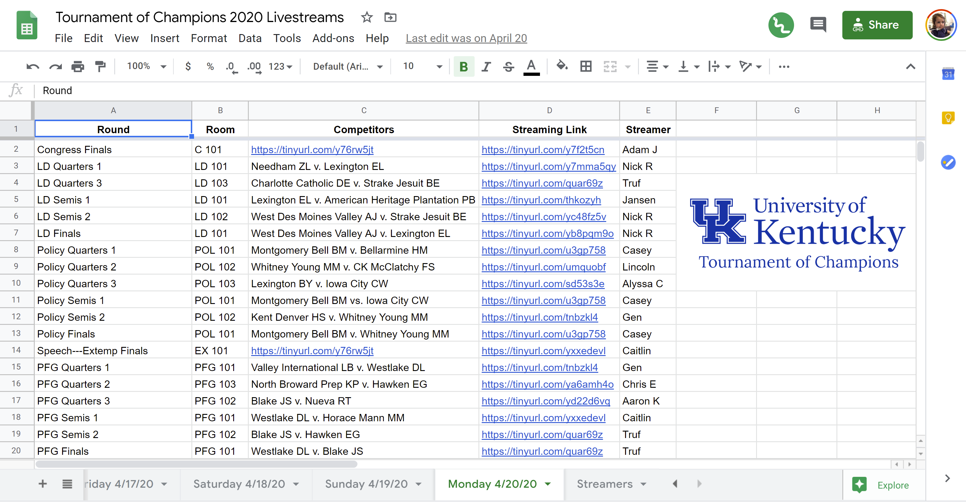

Using a Google Sheet allowed the TOC to share all information about every stream using one single URL. When under heavy web traffic, Sheets can become slow. One way to mitigate this is to publish the Sheet to the web by selecting “File” and the “Publish to the Web”:

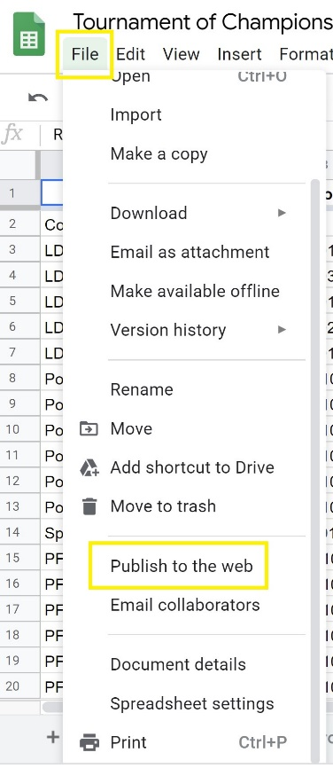

1.3.3 Livestreaming to YouTube

Step 1 – Enable Livestreaming on a YouTube Account

Log into an existing YouTube account or create a new account.

In the upper-right corner, click the Camera icon and select “Go live”:

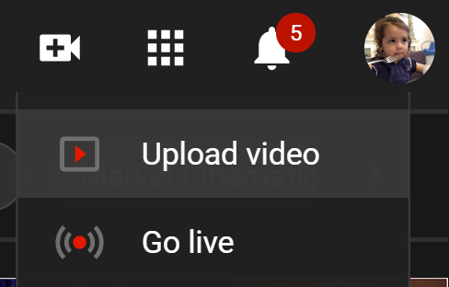

Clicking this link will take you to a page that looks like this:

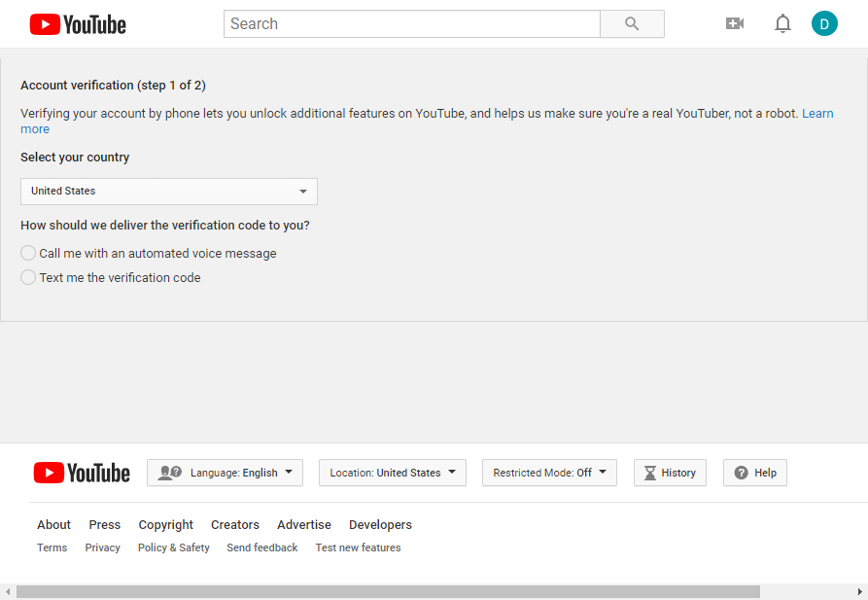

Fill it out and validate your account. If you do this successfully you will see this:

Press “Continue.” Streamers may receive a message that it takes 24 hours to activate the account. After this time, YouTube will automatically enable livestreaming. There is no way to speed up this process, so advanced preparation is required by the streaming team.

Once enabled, bookmark the YouTube Dashboard.

Step 2 – Log into Zoom and Stream to YouTube

Open the Zoom App and be designated the Host of the room. (Note – streamers must be the “host”; they cannot be the “co-host”). Becoming the Host may require assistance from the previous Host or a member of the tournament administrative staff.

In the Zoom App, click the “More” button in the bottom-right corner:

Select “Live on YouTube”:

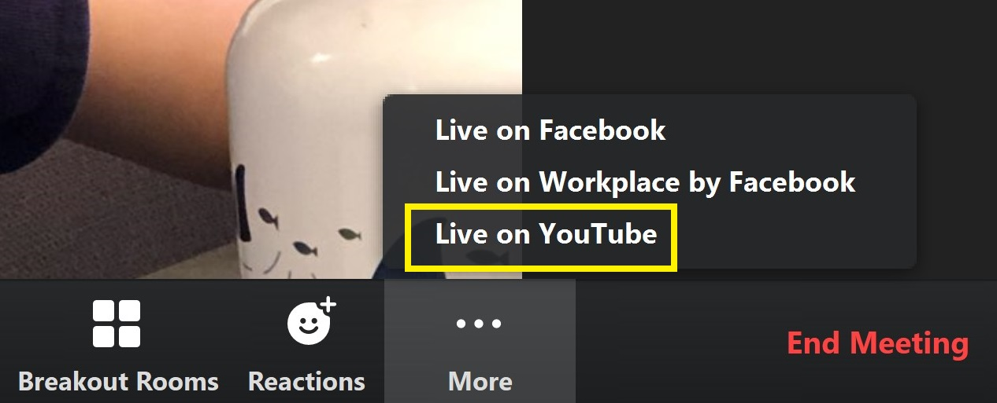

Streamers will be given options to rename their stream (we recommend the format of Tournament---Round---Teams, i.e. “TOC 2020---Policy Quarters---West v. East”) and to change the Privacy setting. For most streams, streamers will want to leave it “Public”. Then click “Go Live!”.
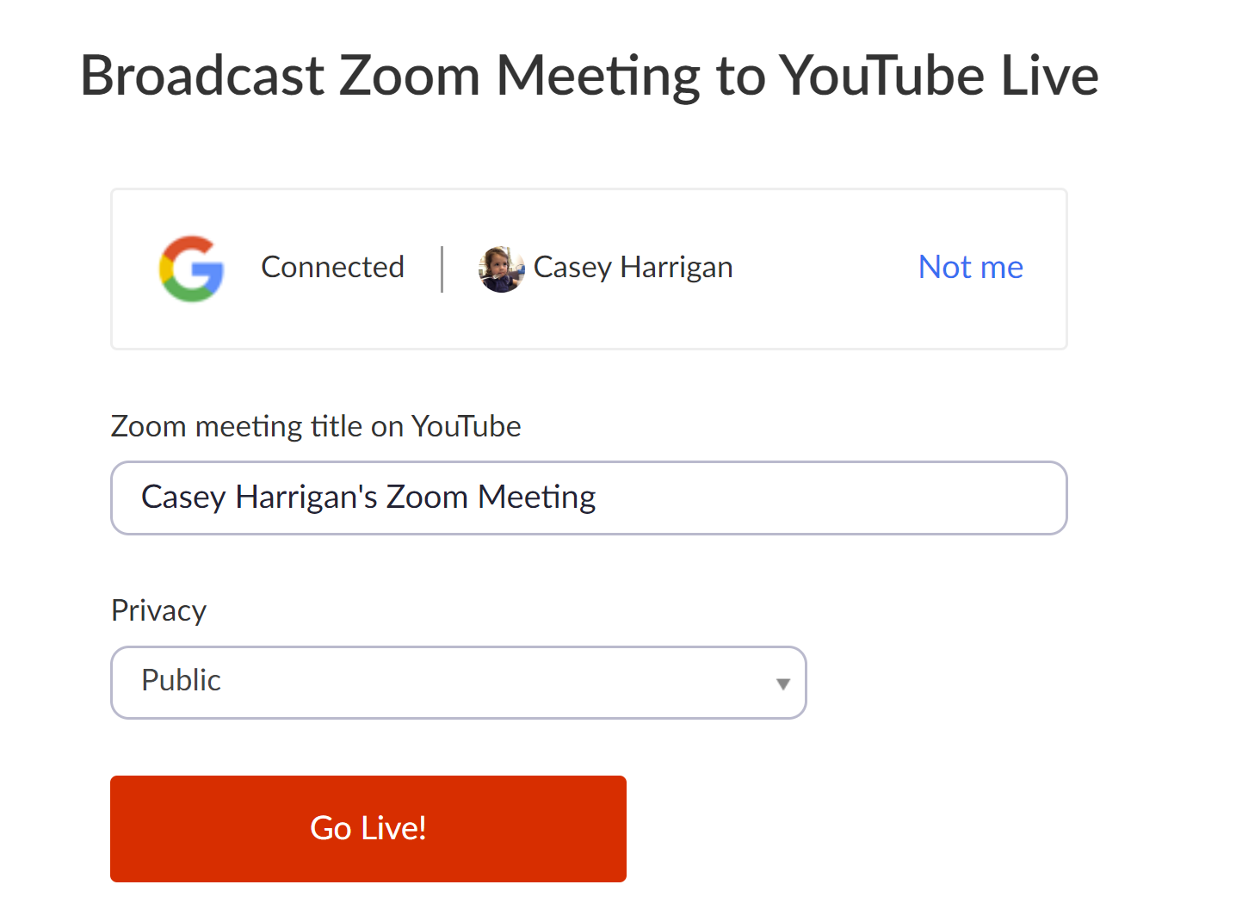

The stream will then be set up:
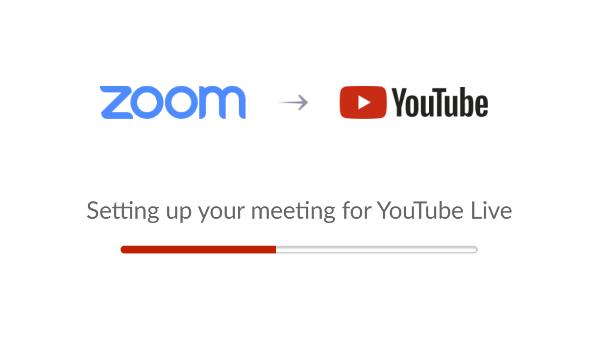
Settings for thee stream can be changed in the YouTube Live Dashboard. Go there and click on the name of the stream:

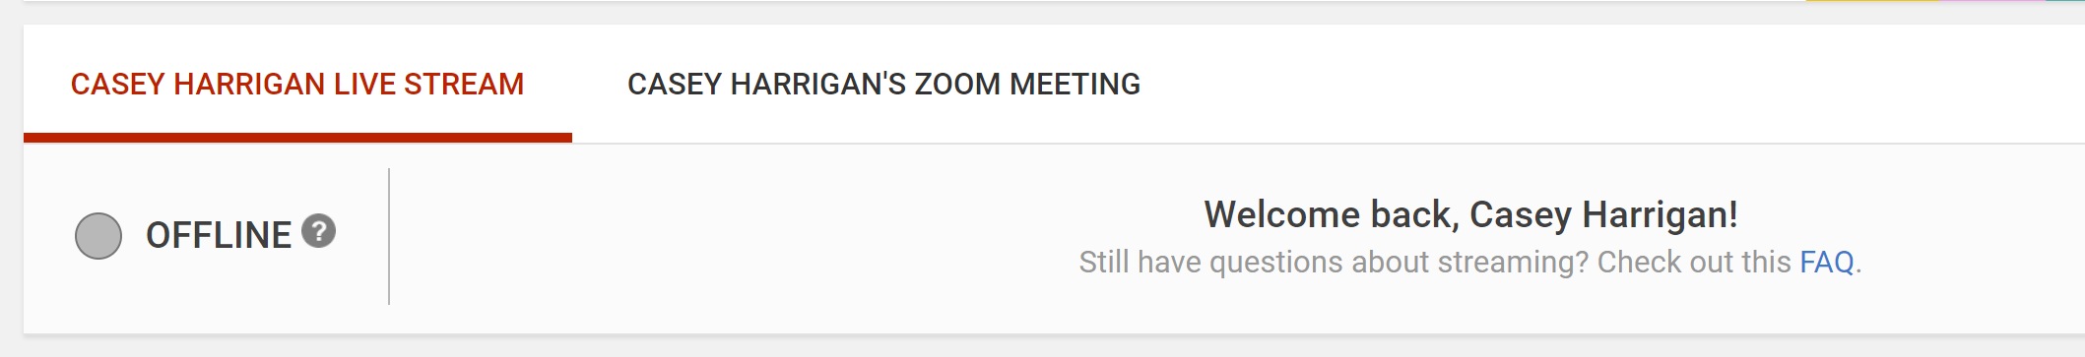

Then, click “Info and Settings” (also note that this avenue provides one means to stop the stream):

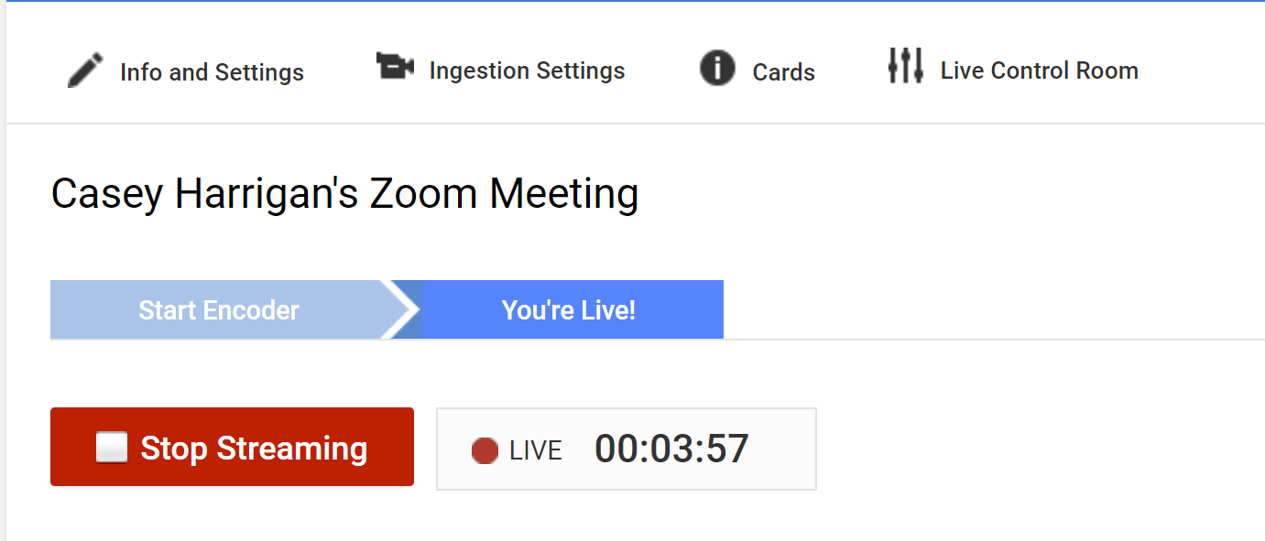

Click “Advanced Settings”:

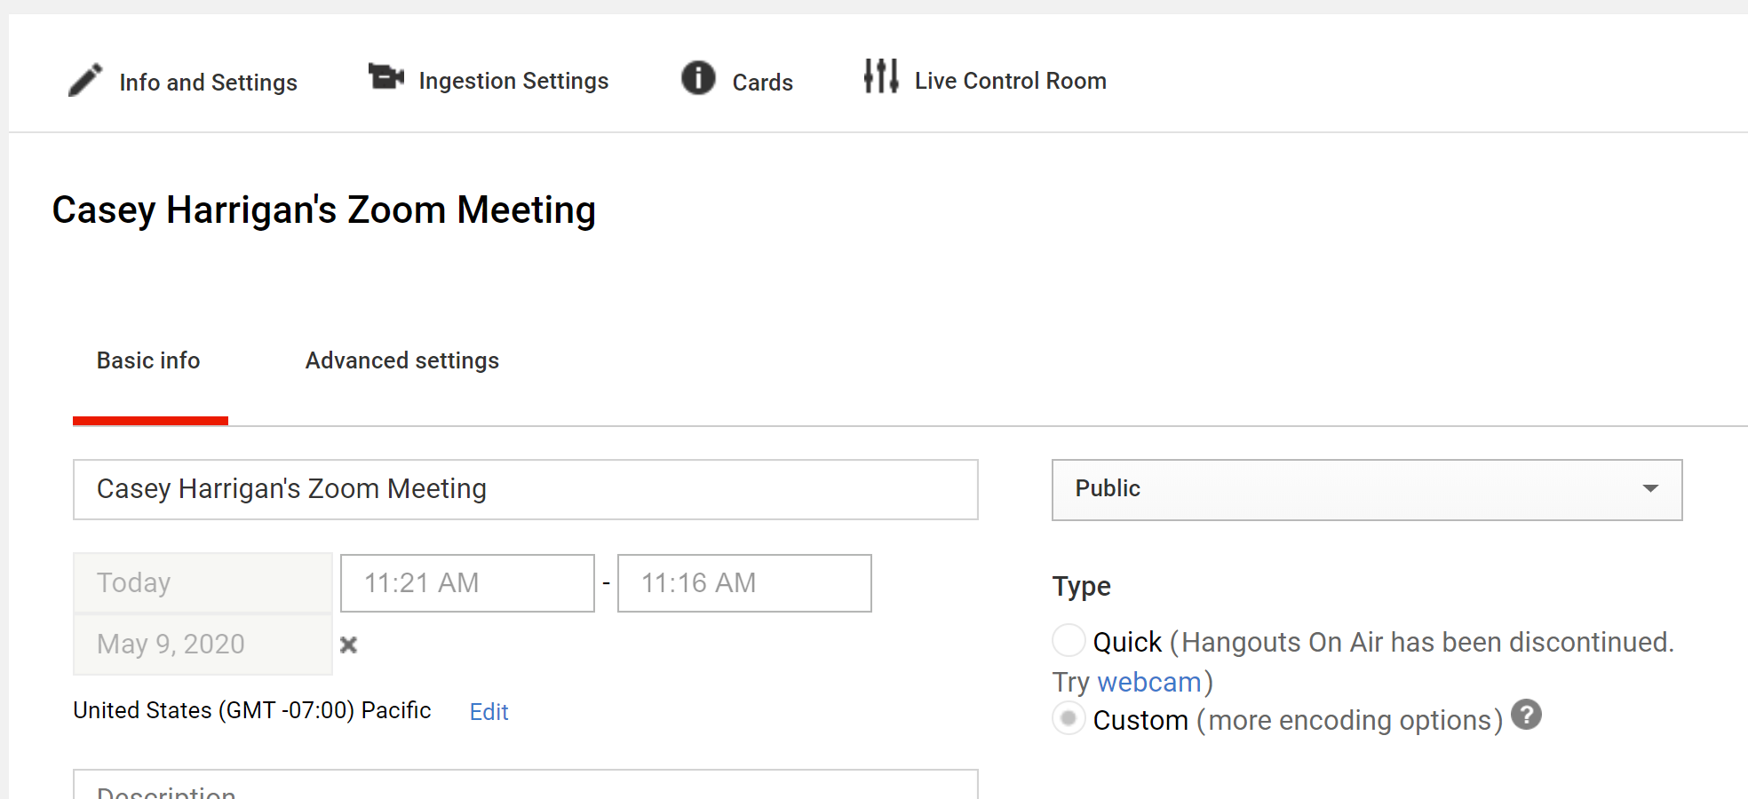

There, streamers can edit the settings for the stream. Settings can be changed to one’s individual preference, but a few used regularly during the TOC are noted. In particular, here are places where streamers can enable/disable chat and comments, set “Education” as the category of video, and set the recording date.

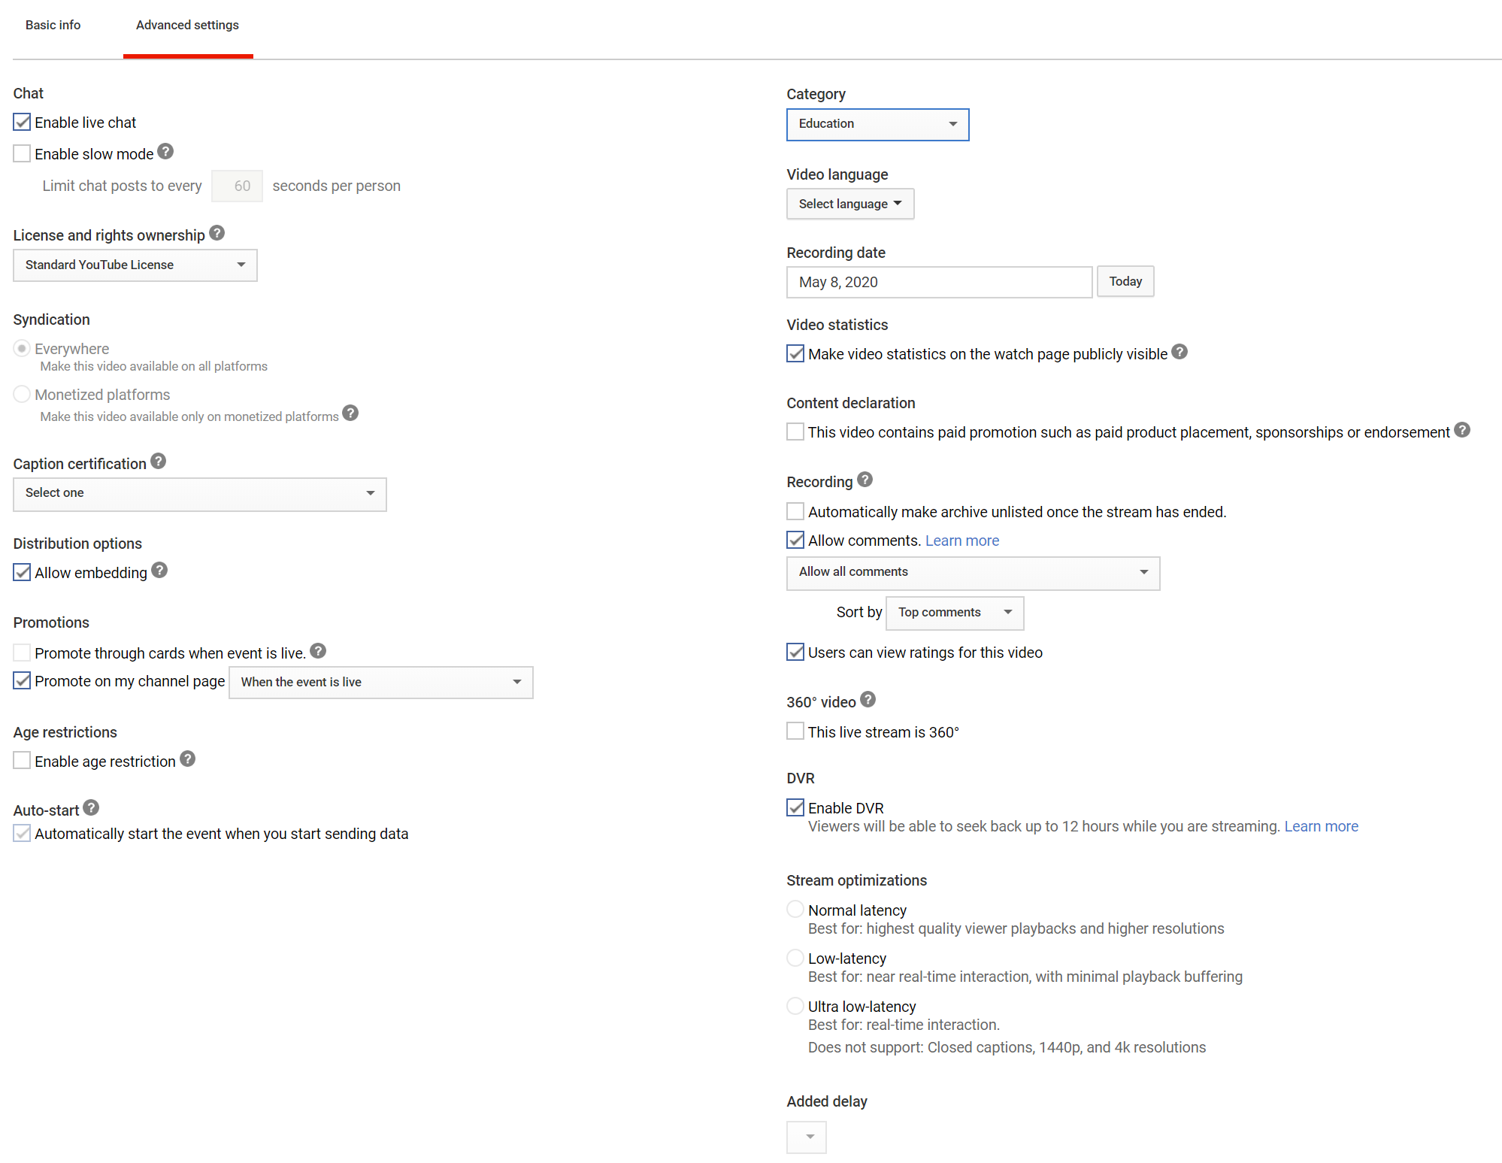

When finished, click “Save Changes” at the bottom right:
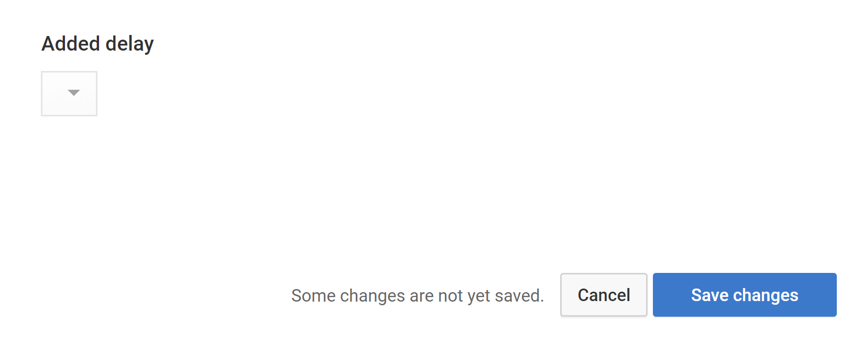
To end the stream, either click “Stop Streaming” from within the YouTube Live Dashboard or go back to the Zoom app and click “More” and then “Stop Live Stream”.

1.3.4 Livestreaming to Facebook

1. Open the Zoom App and be designated the Host of the room.

2. In the Zoom App, click the “More” button in the bottom right corner:

3. Select “Live on Facebook”:

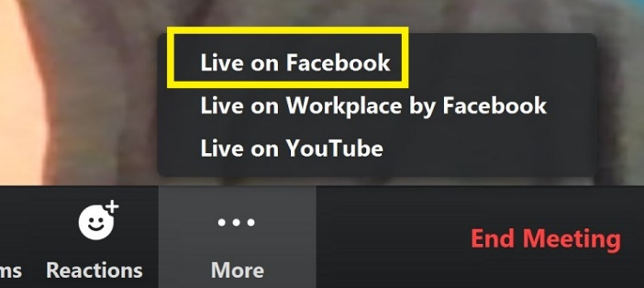

4. Streamers will be redirected to Facebook, where they must have an account. They will see a notification like this:

5. To choose where to share it, click the dropdown menu. Streamers can now choose between sharing on Your Timeline, a Group (e.g. College Policy Debate), or on a Page You Manage (e.g. the University of Kentucky Debate Team page).

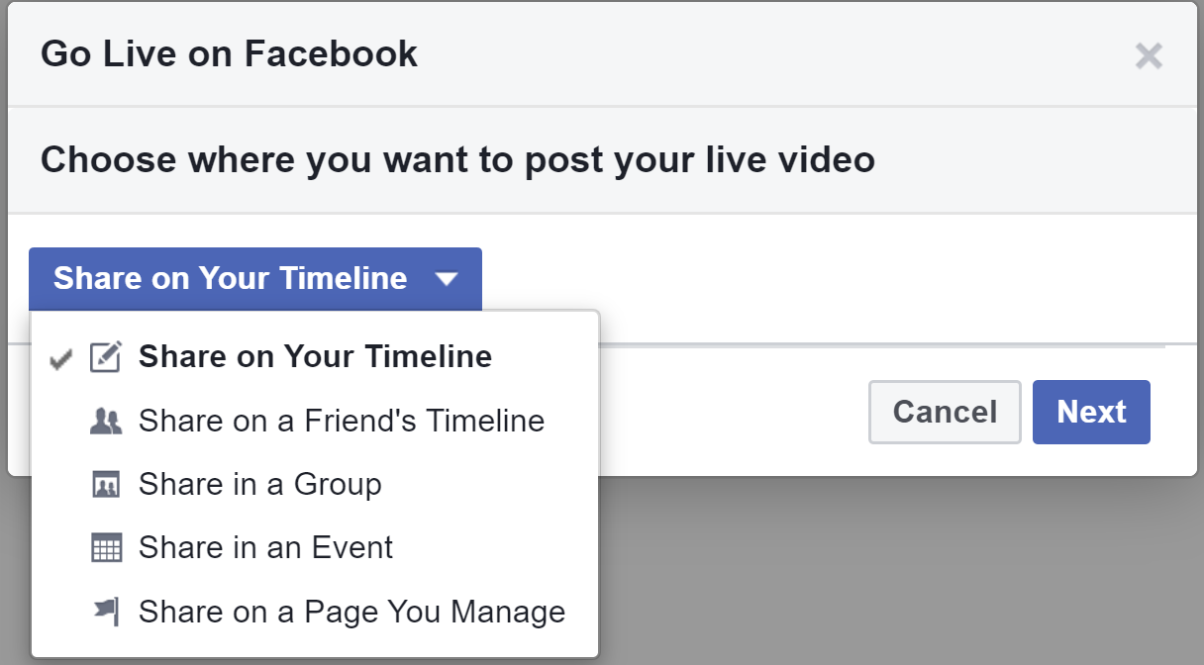

6. Click “Next” and it will go live.

1.3.5 Livestreaming Award Ceremonies

The person who is hosting and streaming the award ceremony should operate the stream and should not be someone who will speak during the ceremony. This person’s job will be to play any media that will be presented, make sure Zoom is displaying the correct speaker, and make sure everyone who is not talking is muted.

Virtual Backgrounds
Speakers may use a “video background” so that everything around them is hidden.

Click the arrow next to “Start Video”:

Click “Choose Virtual Background”:

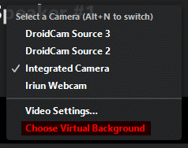

Here, you can select a virtual background. If your virtual background has text in it, make sure to create a mirrored version – otherwise, it will display backwards on other people’s screens.

Host Controls

The host has several controls that affect what is sent to the stream. First, make sure you are in speaker view, which looks something like this:

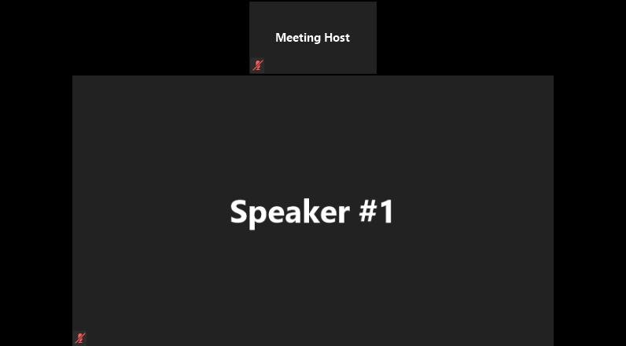

The host can:

1. Pin Videos – Before someone talks, right click their video, and click “Pin Video”:

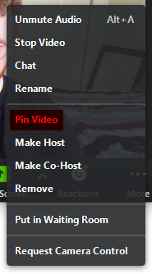

2. Unmute Speakers – Speakers should make sure to unmute themselves before they talk, but if they have forgotten, the host can do that for them:

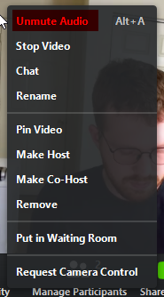

3. Play Media – Open the video you wish to play in advance, and make sure you have closed all unneeded applications. When it is time to play the video, click “Share Screen”:

Select only the window where your video is playing. Select “Share computer sound” and “Optimize Screen Sharing for Video Clip.” Select “Share.”

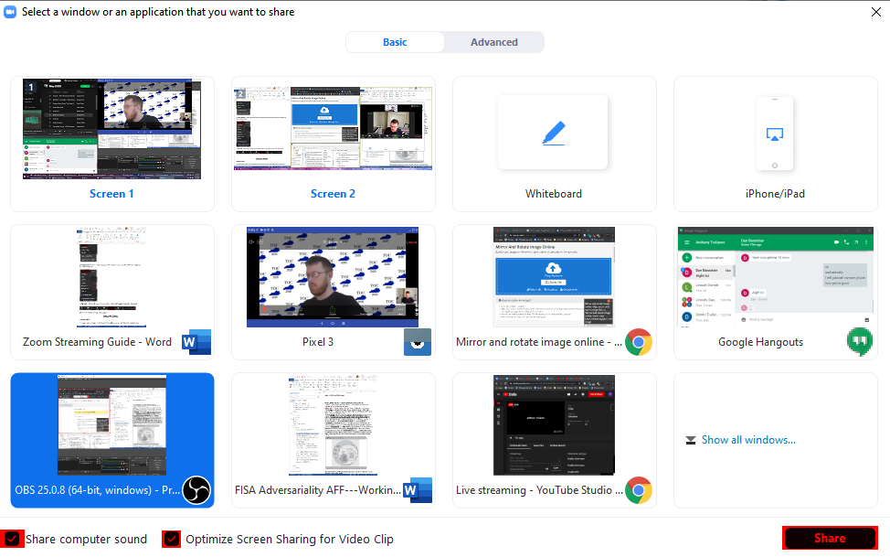

Zoom will disappear, and be replaced by a control panel above the window you are sharing:

Select the full screen option in your video player and play the video. Do not move the mouse or interact with your computer while the video is playing – this will interfere with the playback.

Once the video is finished, mouse over the control panel to bring it up, then press the red “Stop Share” button.

2.0 Event Specific Notes

2.1 Congress

2.1.1 Example Set-Up

TOC 2020 Congressional Debate Final Round.

Video available here.

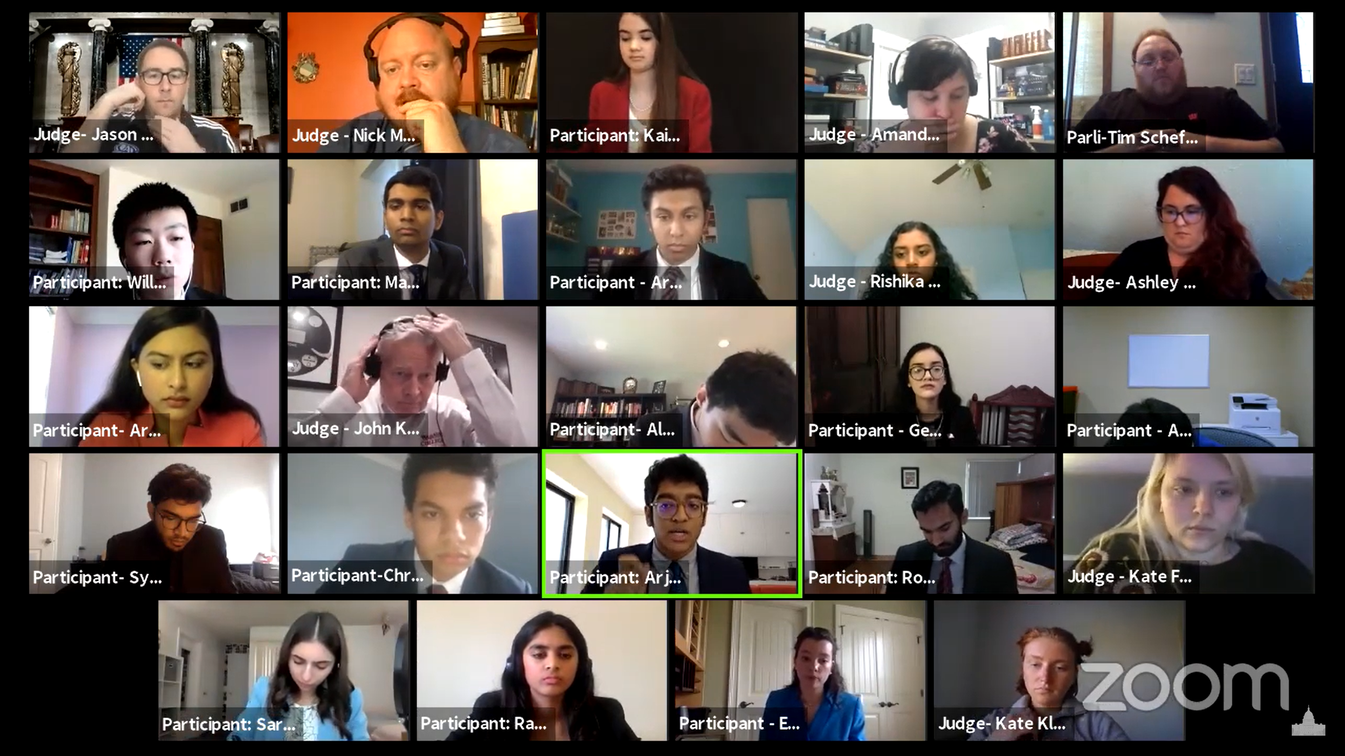

2.1.2 Overview

Zoom app
The Zoom app that is downloaded onto a computer is probably necessary for Congress. The web-based version of Zoom does not have Gallery view, which lets users see everyone in the meeting, not just the active speaker (see above image for example). After round 1 of the TOC, Gallery view was the preferred model.

Session Sizes
15-16 total people (10-12 students, plus judges) worked optimally at the TOC.

Electing Presiding Officers
More work needs to be done to find the best method to poll the room. One key issue is a majority election may require multiple ballots to determine a final outcome and might require "runoff elections" to determine which candidate to eliminate from the ballot. Since being PO might allow a student to advance to semifinals directly, it is important the correct procedures are followed. Normally, we get a paper voting record which allows us to audit the election and determine if the correct candidate was elected. There is a risk basic polling tools may not be used properly by students. More parliamentarian oversight could solve these issues. This is on the list of features that could potentially be built into an online platform.

Precedence and Recency
The most common form of recognition was holding up a placard. Tournaments might want to consider creating a template that participants can download and print prior to the tournament. The POs at the TOC kept a precedence/recency chart on paper, which is standard practice.

Personal Privilege
For personal privilege, most chambers used Chat to indicate a need to "leave the chamber," and the PO acknowledged them at the appropriate time.

2.2 Policy/LD/PF

2.2.1 Example Set-Up

TOC 2020---Policy Debate Round 6---Whitney Young MM v. Montgomery Bell Academy BM. Judge: Nina Fridman.

Video available here.

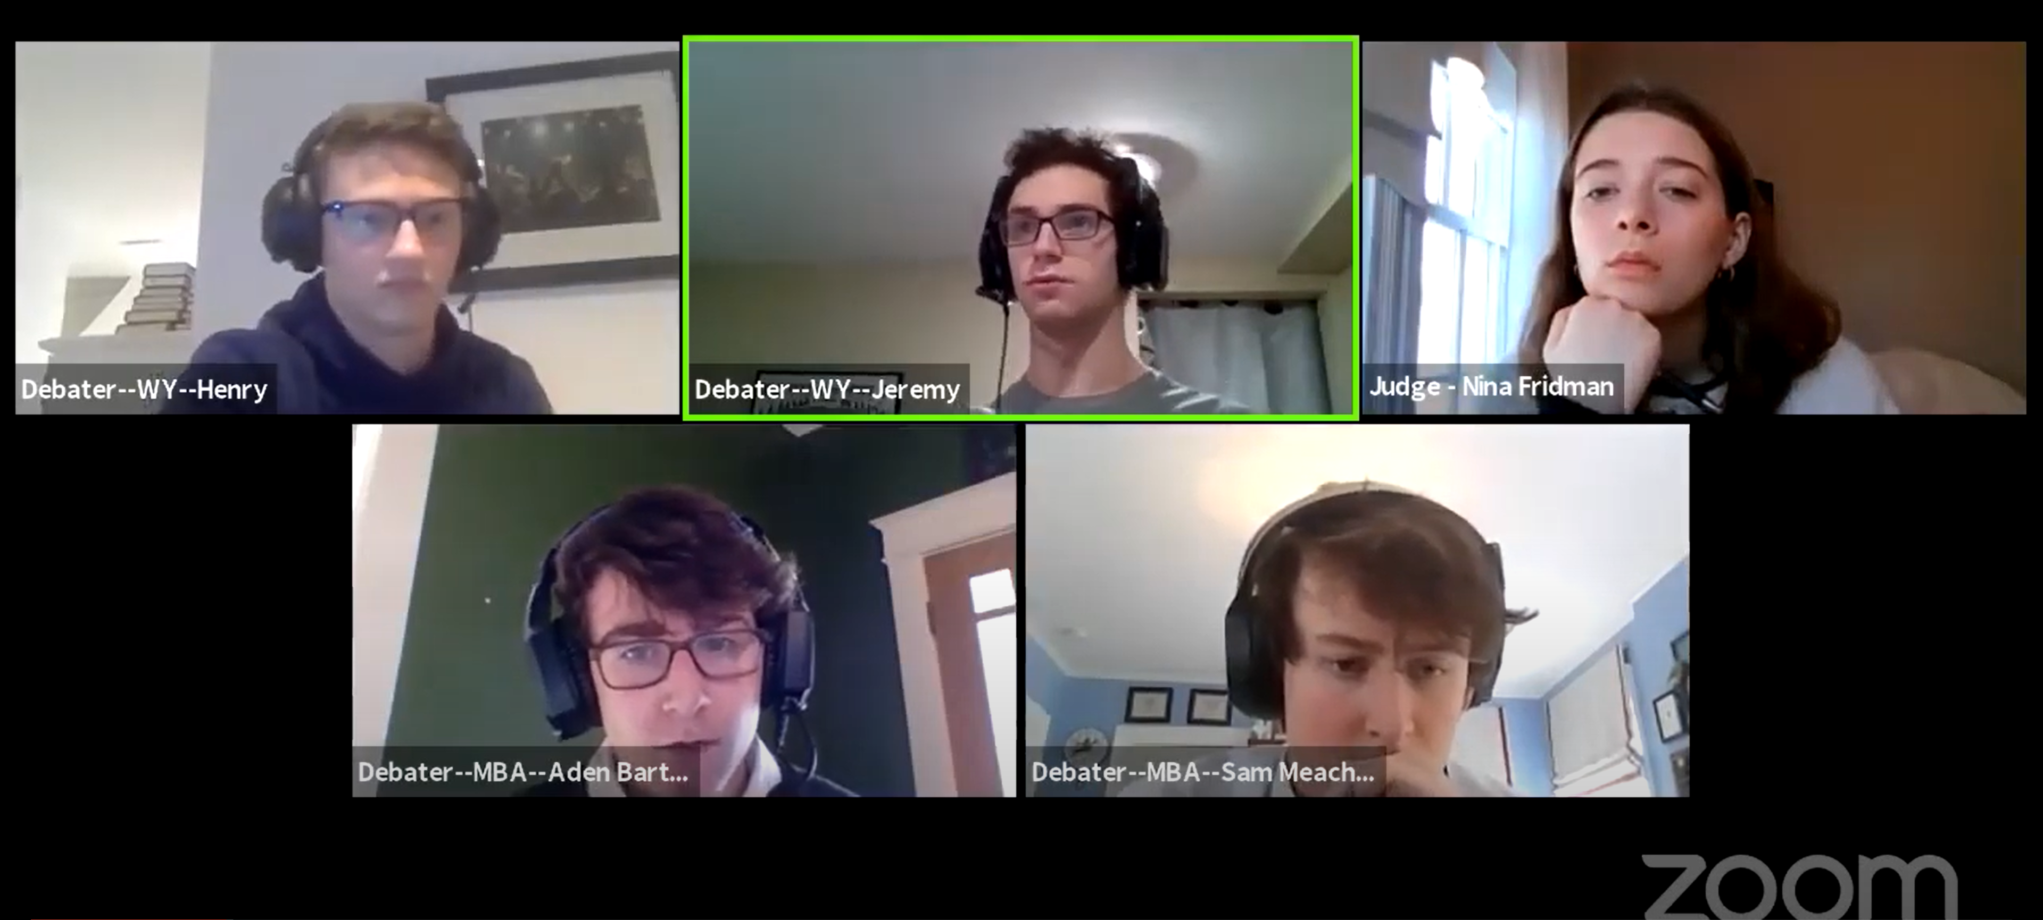

2.2.2 Dealing with Tech Issues

The active speaker should be occasionally checking to make sure that all participants audio is still working/there have not been disconnections.

A useful guide to managing technology situations:

1. The biggest culprit is the internet. Competitors should compete plugged into their router via Ethernet. They should think and talk with their family about minimizing disruptions during competition time in their home. They may consider buying a longer Ethernet cord so they can occupy a quieter section of their home.

2. No one should prepare during any tech downtime (“Tech Time”).

3. If someone is the active speaker, they should take more care to ensure that someone does not lose connection mid-speech. Pausing a speech and then resuming after someone re-connects is the simplest way to resolve technology issues.

4. If a user is a non-active speaker, they should only attempt to pause the active speaker if they have suffered a significant degradation of audio that persists. One second of latency does not warrant pausing a speech. Losing all audio completely does warrant alerting to get the speech paused.

5. Unplugging USB devices like microphones or cameras, then plugging back in, usually fixes most issues.

6. Exiting and reentering the room fixes some issues.

2.2.3 Debating with Remote Partner

PF and Policy debate require debating with a partner. While it may be the case that debaters will be able to co-locate and interact as they would at a brick and mortar tournament, prudent planning suggests that they should prepare to be able to debate remotely, with each participant in a different physical location.

Below are some suggestions for optimizing the process of remote partnerships. To be clear, none are required, and better methods may be discovered through practice. These are merely suggestions to try during practice.

1) Instant written communication – We recommend that debaters and coaches have a shared means of group messaging. In addition to Dropbox, this can be a method of group strategizing and file sharing. The UK Debate team uses Slack. It is free and can provide functionality for an entire team. It also includes the ability to transfer files remotely and create dedicated channels for each two-person team (i.e. if teams want to have communications team-wide, there could be a general channel. But, there is additional capacity to create “breakout” rooms with only specific individuals to streamline communication and avoid clutter). There are other options beyond Slack. Facebook Messenger and Google Hangouts are also reasonable options.

2) Phone – Some amount of preparation between partners is on-the-fly or too time-intensive to type out. For this, we recommend that debaters create a simultaneous phone call between partners. During the pre-round, prep time, and downtime after the debate and before the decision, computer mics can be muted, allowing them to have a private, real-time conversation about arguments. During other times, the phone call can be muted to avoid feedback or any other audio effects. With practice, it may be possible to keep the phone unmuted during other team’s speeches as well, allowing teams to have conversations without interrupting the speaker. Remembering to mute/unmute each input accordingly will require practice, so we recommend that they work on this in practice. Also, it is important that everyone keep their electronics plugged in and charging for the duration to avoid disruption, so locating a long USB charger early is advised.

3) Protocols – Debate is complex; it has always been best practice to streamline activities. In an online environment, the premium for doing so is even higher. This means things like who is responsible for putting together the first affirmative speech, who is responsible for putting together the first negative speech, what the general negative strategy looks like against various affirmative cases, etc. The more that this is set in advance, with clear lines of responsibility, the easier it will be to execute later and to free up bandwidth/time to focus on other elements of prep.

4) Group meetings – One major part of the tournament experience is gathering as a team to discuss arguments read at the tournament, decompress/debrief after rounds, and prep for upcoming debates. This are many possible ways to create a remote version of this. For one, they could create a Zoom meeting. Slack, mentioned above, allows teams to integrate Zoom into their team Slack account and start meetings instantly and seamlessly. These meetings are workable for large or small groups. Teams can also have parallel written side or face-to-face meetings between small groups. Since the TOC utilized the Zoom platform, we recommend that teams use that, but there are many other commercial products available that they may want to experiment with as well.

2.3 Extemp

2.3.1 Example Set-Up

TOC 2020---Extemp Finals

Video available here.

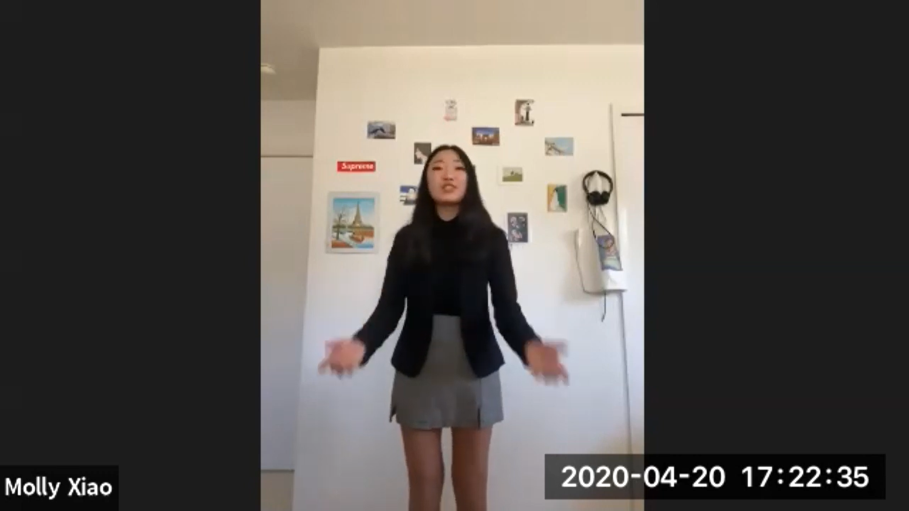

2.3.2 Drawing Questions

Manual Draw
This would involve a tournament staff member having all the questions for the tournament. They enter a breakout room with a student. They communicate the three questions drawn (verbally or in chat). The student selects the question.

The issue with this method is its pace. It is much slower than a face to face prep room with multiple envelopes. One staff member cannot easily facilitate multiple participants drawing questions at the same time virtually if the secrecy of the questions is to be maintained. One way to solve this is have more staff members than typical in an in-person tournament facilitating Extemp draw.

Virtual Draw
At the TOC we partnered with Prepd.in to facilitate Extemp draw virtually. This more closely duplicated the face-to-face experience with all first speakers receiving questions at the same time. While the Prepd method does speed up the tournament the day of, and is simple for users to use, it also has drawbacks. The main drawback at the moment is that Prepd has difficulty integrating with tabulating websites/software. Integrating the Extemp pairing with the virtual draw method is necessary to make sure students receive questions at the right time and they do not receive a question already selected. Prepd overcame this barrier by manually entering in our Extemp pairings into their system. How sustainable such an arrangement can be is unclear. This landscape could change rapidly between now and fall tournaments.

2.3.4 Prep Rooms

It is likely necessary to segment multiple competition rooms into designated prep rooms. Having all competitors meet in one prep quickly becomes unwieldy virtually at a certain number of entries.

Extemp is an event that seems to require the biggest increase in tournament staffing compared to the face to face analog. Where tournaments could have one prep room with one to two people in a face-to-face setting, an online setting takes more prep rooms, more monitors and potentially more people to facilitate draw at a comparable speed.

2.4 Interp Events

2.4.1 Example Set Up

TOC 2020---Program Oral Interpretation Semifinals---Deja Thomas of J. Frank Dobie HS. Video available here.

2.4.1 Live Performances vs. Pre-Recording

Live performances
It is certainly possible to do Interp events live from round to round like a face-to-face tournament. Like most elements of online competition, it comes down to practicing the set-up. Administratively, it is not any more complex than online debate rounds. Tournaments need a judge and a set of competitors in a room at a certain time and tournament staff to ensure they are keeping on a schedule. One issue with live performance is the chance of technology latency or lag and the how much that negatively impacts a performance. In a debate round, the impact is minimal when one to three seconds of a speech is minorly disrupted by connection issues. Can the same be said for a live speech performance?

Recording performances
The TOC utilized pre-recorded performances, in conjunction with the NSDA, using Speeches.cloud. We used a specifically-designed platform because we wanted to minimize the ability to edit videos. We also wanted to ensure that performances were not negatively impacted by technology. The best way we thought to do that was to have a recording that we could audit.

This approach had some drawbacks. First, some competitors had issues uploading videos. Auditing the videos becomes a more time intensive and complex job the more performances involved in the tournament. Some files were corrupt, some files had weak audio, some files were entered in the wrong event, the names did not match what was on Tabroom, etc. Second, processing and storing video files is not free. This could add more costs to running a speech tournament. Third, one performance for a whole tournament is not that close to the face-to-face analog. However, recording more performances magnifies the first two issues.

