Contents
Introduction 2
1.0 Getting Started 2
1.1 Create a Workspace 2
1.2 Finishing Touches 3
1.3 Accepting the Invitation 3
2.0 Using Your Workspace 4
2.1 Create Channels 4
2.2 Using Channels 6
2.3 Adding Someone to a Private Channel 6
2.4 Direct Messages 6
2.5 Apps 8
2.6 Getting More Advanced 9
3.0 Other Issues 10
3.1 I Already Have a Different Slack Workspace 10
3.2 Do I Need to Pay for Slack? 10
3.3 Don’t Like Slack? 10

Introduction

For teams exploring remote coaching options, the TOC would like to encourage considering Slack or similar applications that can help facilitate that transition. The UK Debate team has been successfully using Slack as a platform for several years and considers it an essential tool for coaching, remote or otherwise. It is easy to pick up and use even for the most technically challenged.

The attached guide was produced by University of Kentucky senior Anthony Trufanov. Anthony was the 2019 National Debate Tournament champion and 2015 NSDA champion in policy debate.

1.0 Getting Started

1.1 Create a Workspace

Go to: https://slack.com/

In the upper right corner of the page, you will see a menu button that looks like three horizontal bars. Click it.

Click “sign in” at the bottom of the page.

Click “Create a new workspace.”

Enter your email and click “Next.”

You will see a webpage asking you for a confirmation code. This code should have been emailed to you. Copy paste it into the box.

You will then be asked to name your team. This will be the name of your “workspace.” Do that and hit next.

You will then be asked for a project you are working on. It doesn’t matter what you put here. Put something random and hit “next.”

You will then be asked who you email about your project. This is where you invite other coaches and members of your team. The easiest way to do this in bulk is to click the “Get an invite link to share” button and send it out to everyone you want to be on the Slack.

Click the skip button to move to the next stage. If you are looking at something like this, you have successfully created your workspace:

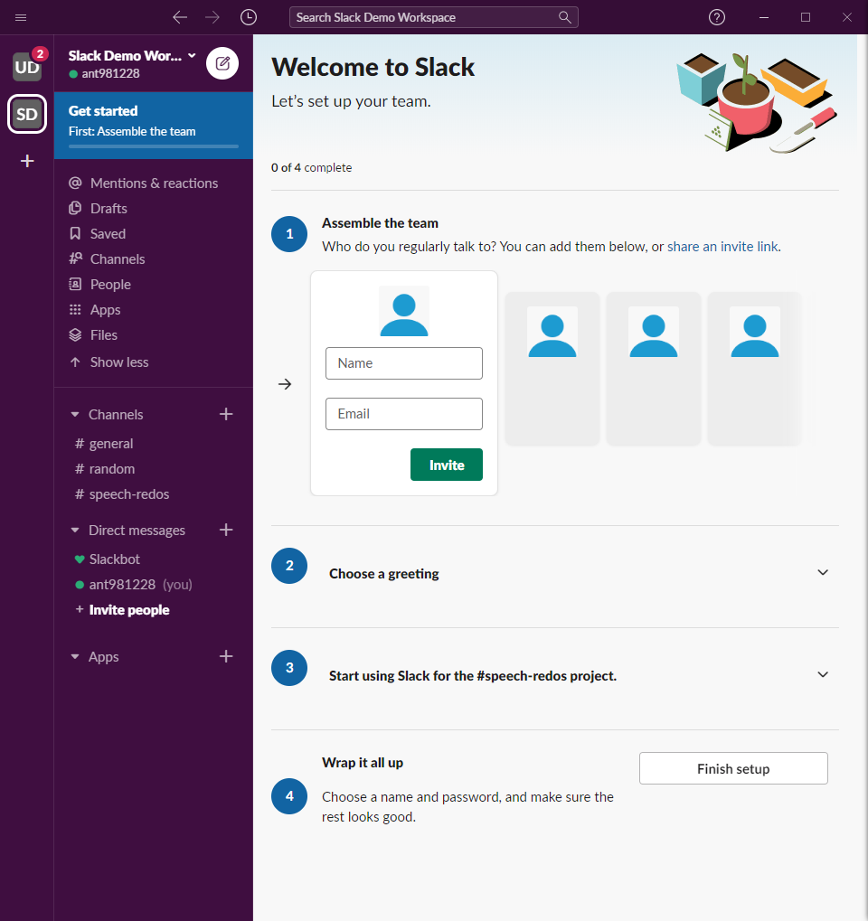

1.2 Finishing Touches

You can invite specific people to Slack in addition to using the invitation link. It is up to you how you want to do this.

The greeting is like the loading screen. You can pick whatever you want.

Hit “Finish setup.” Type in your name and pick a password. Click next.

You will see a screen that lets you pick a name and URL for your workspace. The URL will be how people can log back into the workspace if they log out. Click next.

You will be asked to add people again. Click next.

1.3 Accepting the Invitation

Once you have sent out the invitation link, everyone on your team has to accept the invitation. Clicking the link will take them to a similar page that asks for their email.

Once they enter their email, they will receive a confirmation email with a “Confirm Email” button in it. Clicking this button will send you to a page where you are asked to create an account for your Slack workspace. Type an email and password and hit create account.

You should now have access to the workspace.

The first time you click on a public channel, you will be asked if you want to join the channel. Slack does this to avoid sending every workspace member notifications about channels that aren’t relevant to them. Press the button to confirm you want to join the channel.

2.0 Using Your Workspace

2.1 Create Channels

Think of channels like email threads – they are chats about particular subjects that can include all or part of your team. You’ll notice that whatever you typed in when you said what project you are working on has been turned into a channel.

The best organizational scheme for this will depend on the event. One way to do it is to create a channel for each team or competitor to enable targeted coaching. Another way is to create channels dedicated to substantive subsets of your preparation – for example, a public forum team might have a channel for pro and a channel for con.

The University of Kentucky policy debate team has a channel for the affirmative side, a channel for the negative side, and a chancel for each partnership. We use the “general” channel for logistics – checking in in the morning, etc.

To create a channel, click the “+” button next to channels and click “Create a channel.”

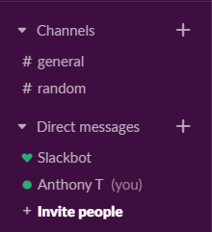

Type in a name and description.

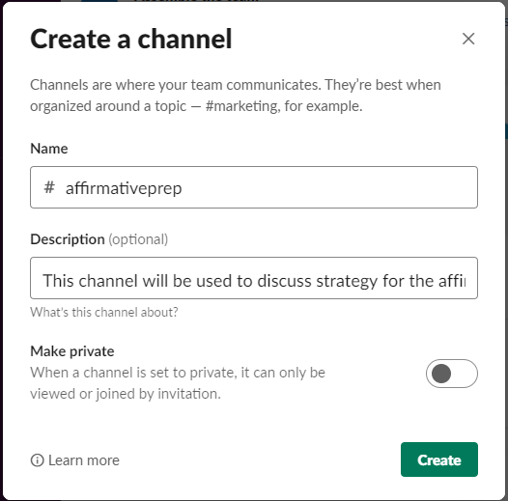

Private channels are useful if you want certain discussions to only be accessible to a subset of the team. One example could be a “coaches” channel for general coaching conversations. Another example could be channels for individual speakers or partnerships which you don’t want to be accessible to the rest of the team.

Click “Create.” Your new channel will appear in the list of channels.

2.2 Using Channels

To send a message, open the channel you want, type a message in the message box at the bottom, and press enter.

To reply to a specific message, mouse over that message and click the speech bubble icon labeled “Start a thread.”

To send someone a notification, type @ and then their name. To send the whole channel a notification, type “@channel.”

To send a file, press the paper clip at the bottom right corner of the message box, and click “Your computer.” This will open a dialogue box that asks if you want to add a message about the file. Do that if you want and click “Upload.” To download a file, mouse over the file and click the cloud icon with a down arrow. A sidebar will pop up on the right that lists all the files you have shared in the channel. Click the one you want to open.

2.3 Adding Someone to a Private Channel

The easiest way to add someone to a private channel you have already created is to mention them using the @ system.

Doing this will show a dialogue box saying the person you are mentioning isn’t in the channel, and asking if you want to add them. Click “Invite to Channel.”

2.4 Direct Messages

Direct messages are more akin to texting or messaging you can do on any other platform.

You can message one person or create a group chat. Create new direct messages by pressing the “+” button next to Direct messages:

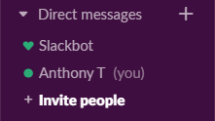

OR by pressing the “Compose” button (the white button at the very top that looks like a square and a pencil):

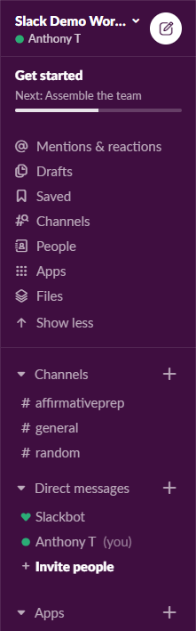

2.5 Apps

Apps are add-ons that can increase Slack’s functionality. They are entirely unnecessary for using Slack if you don’t want to use them, but some of them are helpful.

To add an app, press the “+” button next to “Apps.” This will take you to a list of the most popular apps and a search bar.

Zoom
You can integrate Zoom with Slack. Zoom should be near the top of the recommended list. Find it and press “Add.”

This will open a webpage that describes the app and lets you confirm that you want to add it. Press “Add to Slack.”

You will then be asked if you want to add Zoom “company-wide” or just for your Slack account. Press “company-wide.”

You will then be asked to sign into Zoom. Do that.

You will then be asked to confirm that you want Slack to be able to access Zoom. Press “Authorize.”

You will then be asked to select your Slack workspace. Press “Connect to Slack workspace.”

You will then be asked about authorization again. Press “Allow.”

This video explains how to use Zoom for Slack.

Other useful apps
Polly lets you poll your team and do simple surveys

Google calendar or outlook calendar let you schedule meetings and send invitations for events

2.6 Getting More Advanced

Slack is an incredibly powerful platform with a lot of versatility and a lot of ability to integrate with other digital services you are using. There are plenty of guides online that explain how to use the platform most effectively.

Here is Slack’s how-to guide.

One thing to be aware of is that in the last few weeks Slack was significantly redesigned. Nearly all of the functionality has remained unchanged, but some of the older guides might look a little bit different.

3.0 Other Issues

3.1 I Already Have a Different Slack Workspace

The way slack works is that you have an account for each workspace you create, so you will still have to go through the steps above if you are making a new workspace for your speech or debate team.

3.2 Do I Need to Pay for Slack?

No. The difference between the free and paid versions is that the free version will prevent you from accessing your old messages. However, the limit is so high that it does not have a practical effect, especially if you only plan to use Slack for a month.

3.3 Don’t Like Slack?

If you hate Slack, there are other online coaching options you can try.

A popular alternative is Microsoft Teams. This has a lot of the same core functionality. Chanty is a more basic team chat app. If you search google for Slack alternatives there are plenty of options. However, we recommend Slack because we have found that it offers the best balance of usability and functionality.

